**Practical 1**

**Colour code for crimping LAN (Cat 5/6/7) cable**

Aim:

1. Study of Different colour codes
2. Study of different connecting devices and their differences
3. Crimping LAN Cable

**Theory:**

**CAT 5, CAT 6, and CAT 7**

CAT 5, CAT 6, and CAT 7 are different generations of Ethernet cables, each with varying characteristics. Following are the key differences between them:

1. Speed and Bandwidth:

CAT 5: It supports data transfer speeds up to 100 Mbps (Megabits per second) with a maximum bandwidth of 100 MHz. CAT 5 cables are considered outdated and are rarely used for new installations.

CAT 6: It supports data transfer speeds up to 10 Gbps (Gigabits per second) with a maximum bandwidth of 250 MHz. CAT 6 cables are commonly used for home and small office networks.

CAT 7: It offers higher performance with data transfer speeds up to 10 Gbps and beyond, reaching up to 40 Gbps. It has a higher bandwidth capacity of 600 MHz. CAT 7 is designed for more demanding applications and larger network infrastructures.

1. Shielding:

CAT 5: It is typically an unshielded twisted pair (UTP) cable, meaning it does not have any shielding to protect against electromagnetic interference (EMI) or crosstalk.

CAT 6: It can be either unshielded twisted pair (UTP) or shielded twisted pair (STP) cable. Shielded variants have additional shielding to reduce EMI and crosstalk.

CAT 7: It features additional shielding known as individually shielded pairs (S/FTP or S/STP). This shielding provides better protection against EMI and crosstalk, leading to improved signal quality and reduced interference.

1. Connectors and Backward Compatibility:

CAT 5: It commonly uses RJ-45 connectors, which are the standard connectors for Ethernet cables. CAT 5 cables are backward compatible with newer Ethernet standards like CAT 5e, CAT 6, and CAT 7.

CAT 6: It also uses RJ-45 connectors, and CAT 6 cables are backward compatible with CAT 5 and CAT 5e.

CAT 7: It uses specialized RJ-45 connectors with stricter specifications to ensure better signal integrity at higher frequencies. CAT 7 cables are backward compatible with older Ethernet standards as well.

1. Distance:

CAT 5: It is suitable for shorter distances within a network, typically up to 100 meters (328 feet).

CAT 6: It can also reach up to 100 meters for 10 Gbps speeds but may have reduced performance at longer distances.

CAT 7: It can achieve 10 Gbps speeds at longer distances, typically up to 100 meters (328 feet).

**RJ45 Pin-out Ethernet Cables and Colour codes**

Ethernet LAN cables can come in two types – Crossover or Straight through. The following are the pin-outs for the RJ45 connectors

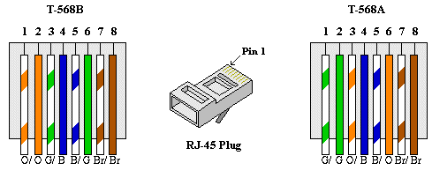

There are two different pin-out standards used worldwide, and depending on location, we determine which one to use.

T568A is used in America and Asia and

T568B is used in Britain and Europe

**Different connecting devices and their differences:**

There are several different connecting devices used in computer networks. Here are the most common ones and their key differences:

1. Hubs:
2. Hubs operate at the physical layer of the network.
3. They have a single collision domain, meaning all connected devices share the same bandwidth.
4. They broadcast incoming data to all connected devices, regardless of the intended recipient.
5. Hubs are considered outdated and are rarely used in modern networks.
6. Switches:
7. Switches operate at the data link layer of the network.
8. They create individual collision domains for each connected device, allowing for simultaneous communication.
9. Switches use MAC addresses to direct incoming data to the appropriate device.
10. They offer better performance, security, and scalability compared to hubs.
11. Routers:
12. Routers operate at the network layer of the network.
13. They connect multiple networks or subnets and forward data packets between them.
14. Routers use IP addresses to route traffic based on network protocols.
15. They provide network segmentation, enable interconnectivity, and enforce security policies.
16. Bridges:
17. Bridges operate at the data link layer of the network.
18. They connect two network segments and filter network traffic based on MAC addresses.
19. Bridges help to reduce network congestion and improve overall network performance.
20. They are commonly used to extend network coverage and create smaller broadcast domains.
21. Repeaters and Extenders:
22. Repeaters and extenders amplify or regenerate network signals to extend their reach.
23. Repeaters operate at the physical layer, while extenders work at higher layers.
24. Repeaters boost analog signals, while extenders can amplify both analog and digital signals.
25. Repeaters and extenders are primarily used in long-distance or large-scale network deployments.

**Crimping LAN Cable**

Crimping LAN wires, also known as Ethernet cables, involves attaching RJ-45 connectors to the ends of the cable. Here are the steps to crimp LAN wires:

1. To Gather the necessary tools and materials:
2. Ethernet cable (UTP or STP)

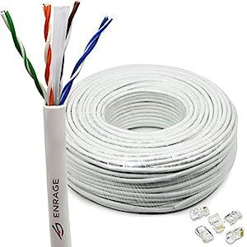

1. RJ-45 connectors (usually 8P8C)

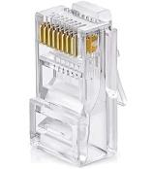

1. Crimping tool

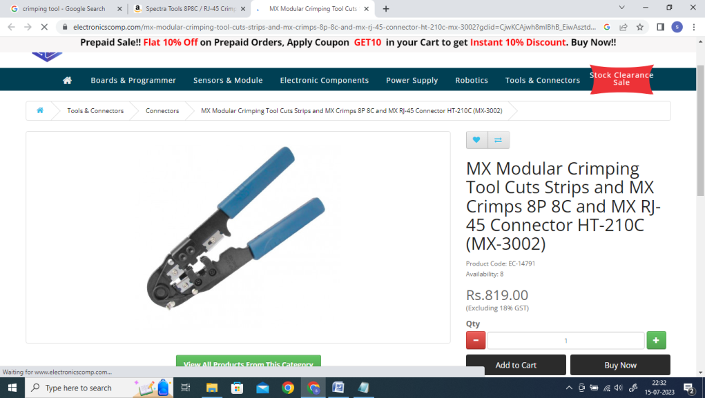

1. Cable cutter/stripper

| 71KYEHr1xjS | OR |  |
| --- | --- | --- |

1. Cable tester (Optional)

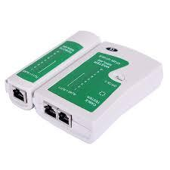

1. Measure and cut the cable:

Determine the desired length of the LAN wire and cut the cable accordingly. Use a cable cutter to make a clean, straight cut.

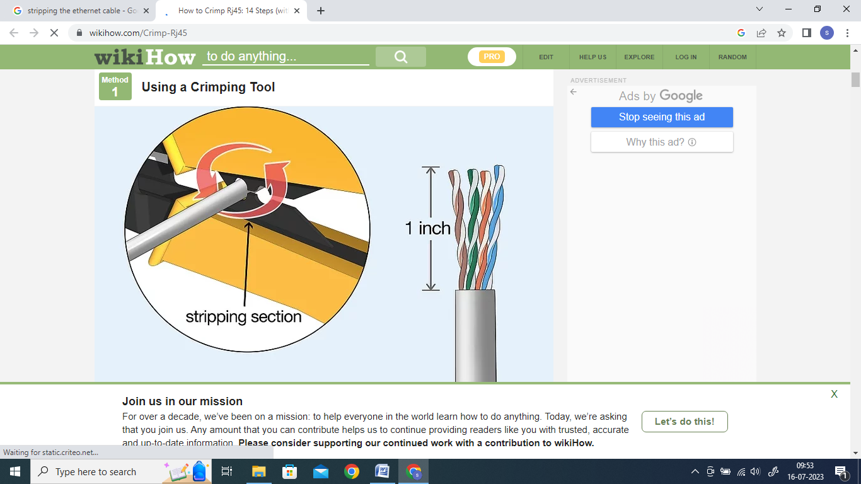

1. Strip the cable jacket:

Use a cable stripper or a sharp blade to carefully remove approximately 1-1.5 inches (2.5-3.8 cm) of the outer jacket from the cut end of the cable. Be cautious not to damage the internal wires.



1. Untwist and arrange the wires:

After removing the jacket, you'll find four twisted pairs of coloured wires inside.

Untwist the pairs and arrange them according to the desired wiring standard (T568A).

Make sure to maintain the same order on both ends of the cable.

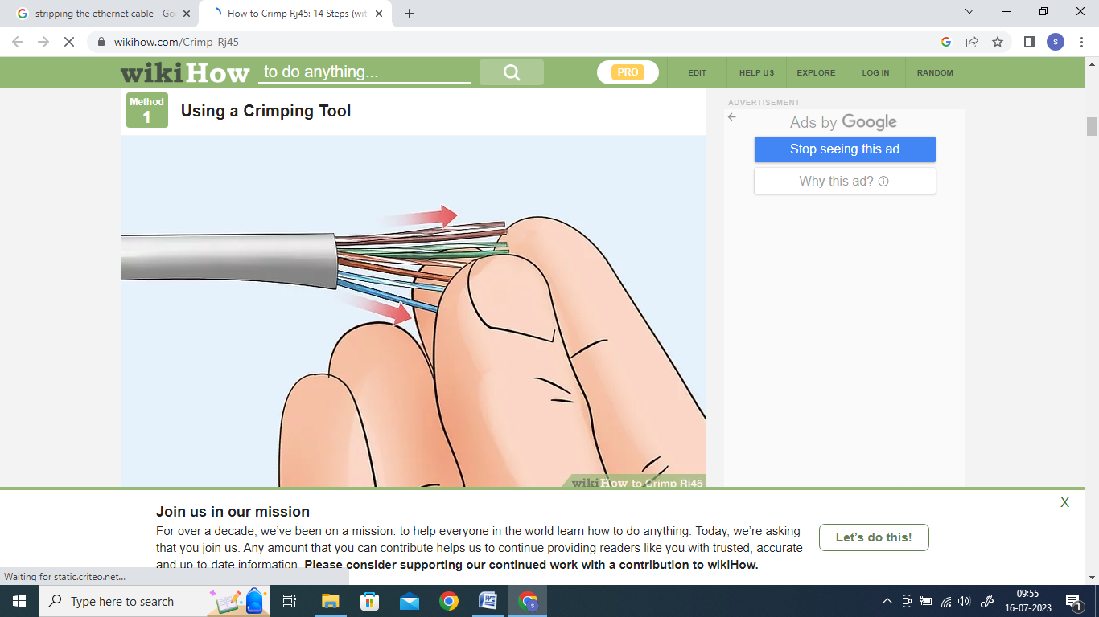

1. Trim and straighten the wires:

Cut the excess wire length to ensure they are even and of equal length, typically around 0.5 inches (1.3 cm).

Use your fingers or a wire straightened tool to align the wires neatly and make them easier to insert into the connector.

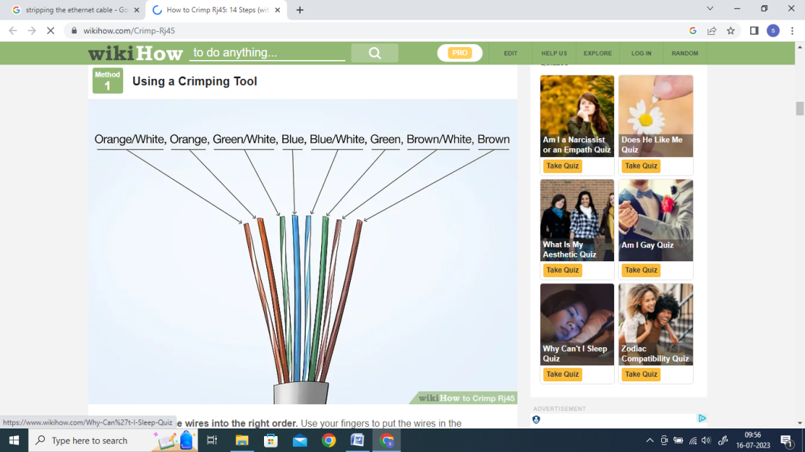 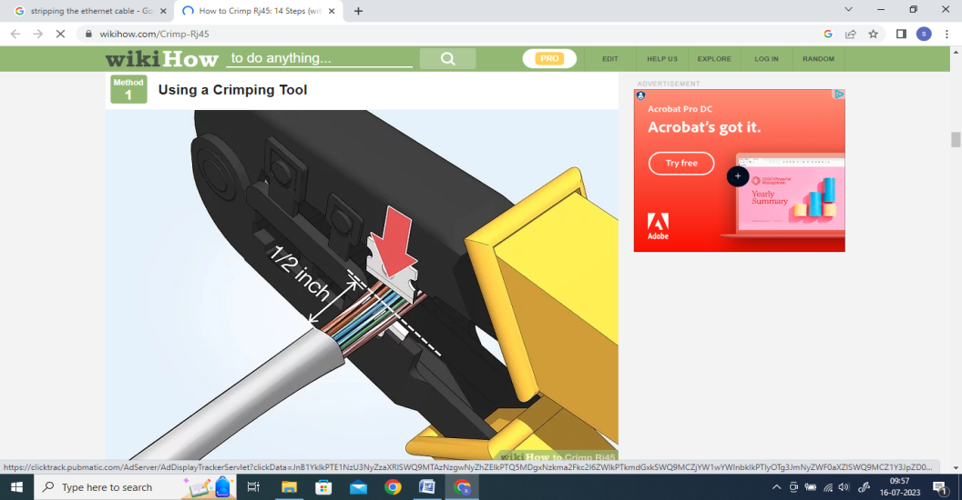

1. Insert the wires into the connector:

Carefully insert the arranged wires into the RJ-45 connector, ensuring they reach the end and make contact with the metal contacts inside. Check that the wire colours are in the correct order.

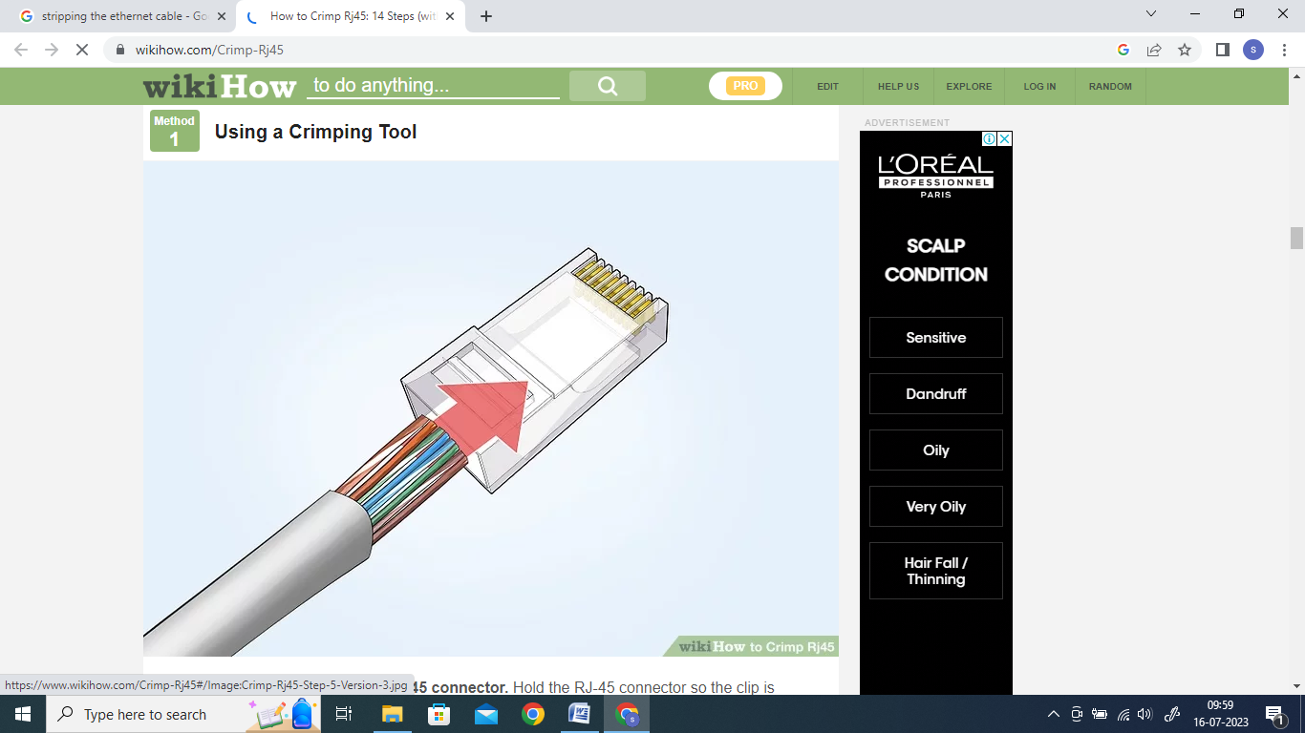

1. Crimp the connector:

Place the connector and cable into the appropriate slot of the crimping tool, ensuring it is properly aligned.

Squeeze the handles of the crimping tool firmly to crimp the connector. This action will secure the wires in place and create a strong connection.

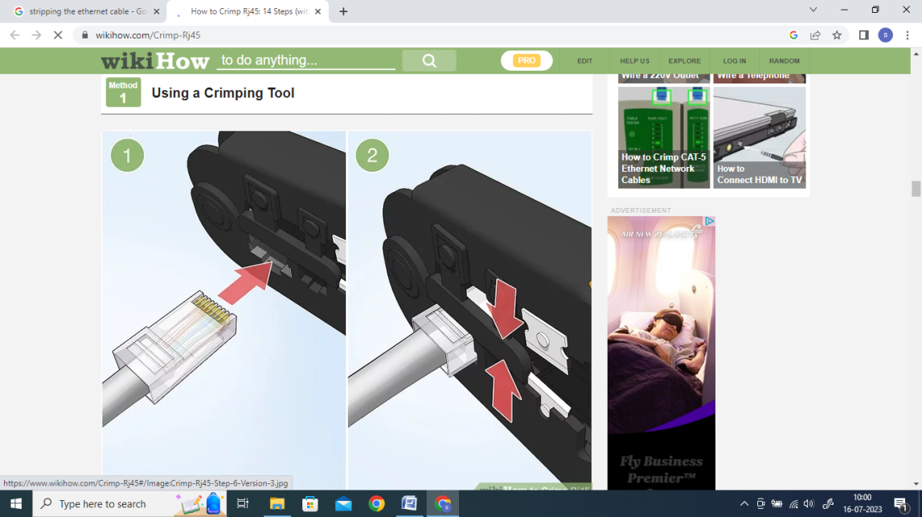

1. Repeat for the other end:

Repeat steps 3 to 7 for the other end of the LAN wire, ensuring that both ends follow the same wiring standard.

1. Test the cable (optional):

If available, use a cable tester to verify the connectivity and integrity of the crimped LAN wire. The tester will check for proper wire order and continuity.

By following these steps, we can crimp LAN wires and create custom Ethernet cables as per network requirements.

**Practical 2**

**Configuring LAN setup**

Aim:

1. Planning and Setting IP networks
2. Configuring subnet
3. Study of basic network command and Network configuration commands. ipconfig, netstat, ARP, ping, trace route etc.
4. Basic network troubleshooting.
5. Configuration of TCP/IP Protocols in Windows / Linux.
6. Implementation of Drive/file sharing and printer sharing.

Part a) Planning and Setting IP networks

Planning and setting up IP networks involves several key steps and considerations to ensure a reliable, scalable, and secure infrastructure.

Following points are needed to be considered:

1. Define Network Requirements:

We start by understanding the needs of the organization or project. Identify the number of devices to be connected, the expected network traffic, geographical locations, security requirements, and any future expansion plans.

1. Choose IP Addressing Scheme:

Decide on the IP addressing scheme we would use, whether it's IPv4 or IPv6. For IPv4, we need to choose a private IP address range and ensure it doesn't conflict with any existing networks we might connect with.

1. Design Network Topology:

Determine the network's physical layout and logical topology. Consider factors like the number and location of switches, routers, subnets, and how devices will connect to each other. This design should align with requirements and accommodate potential growth.

1. Subnetting:

Divide IP address space into smaller subnets to help manage network traffic efficiently and improve security. Subnetting also enables us to isolate different departments or devices based on their functions.

1. Choose Network Equipment:

Select routers, switches, firewalls, and other network equipment based on the network's size, expected traffic load, and the specific features and capabilities needed to meet our requirements.

1. IP Address Assignment:

Decide how IP addresses will be assigned to devices. This can be done manually (static IP) for critical devices and servers, or dynamically (DHCP) for less critical devices. DHCP automates IP address assignment and makes it easier to manage larger networks.

1. Configure Network Devices:

Set up the routers, switches, and firewalls based on the network design. Configure routing protocols, VLANs (if necessary), security policies, Quality of Service (QoS) settings, and any other required features.

1. Implement Network Security:

Security is crucial in any network. Set up firewalls, intrusion prevention systems (IPS), and other security measures to protect against unauthorized access and potential threats. Regularly update firmware and keep security patches up to date.

1. Testing and Troubleshooting:

Before deploying the network in a production environment, conduct thorough testing to identify and resolve any configuration issues or performance bottlenecks. Verify connectivity, test for any security vulnerabilities, and ensure proper functioning of all network services.

1. Documentation:

Document the entire network setup, including IP addresses, subnet masks, network diagrams, device configurations, security settings, and any other relevant information. This documentation will be valuable for future troubleshooting, maintenance, and upgrades.

1. Monitoring and Maintenance:

Implement network monitoring tools to keep an eye on the network's health and performance. Regularly monitor for any anomalies, assess network usage patterns, and perform necessary maintenance tasks like updating firmware, renewing SSL certificates, and checking for security updates.

1. Network Scalability:

Plan for future growth and scalability. As the network expands, we must be ensured it can accommodate additional devices and increased traffic without major disruptions.

We do the following case-study in this respect

Consider a small business called "Smile Info-solution Inc.," which provides IT services to local businesses in their city. They need to plan and set up an IP network for their office to support their internal operations and offer IT services to their clients.

1. Define Network Requirements: Smile Info-solution Inc. has 30 employees, including 20 desktop computers, 10 laptops, 5 network printers, and a file server. They also want to set up a guest Wi-Fi network for visiting clients.

2. Choose IP Addressing Scheme: They decide to use IPv4 for their network and choose the private IP address range 192.168.1.0/24 for their internal devices. They'll use DHCP to assign IP addresses dynamically to employee devices and printers.

3. Design Network Topology: They plan to use a star topology for their office network. The main switch will connect to all the desktop computers, printers, and the file server, while a separate wireless access point will handle the guest Wi-Fi network.

4. Subnetting: They divide the IP address range into two subnets: one for employee devices (192.168.1.0/25) and one for the guest Wi-Fi network (192.168.1.128/26).

5. Choose Network Equipment: Smile Info-solution Inc. selects a business-grade router, a managed switch, and a wireless access point that supports VLANs to separate employee and guest networks.

6. IP Address Assignment: They configure DHCP on the router to assign IP addresses to employee devices and printers in the range 192.168.1.2 to 192.168.1.126. The guest Wi-Fi network will use DHCP for IP addresses from the range 192.168.1.130 to 192.168.1.190.

7. Configure Network Devices: They set up the router with appropriate routing protocols, firewall rules, and port forwarding to secure the network and allow remote access for their clients' devices when needed. The switch is configured with VLANs to segregate traffic from the two networks.

8. Implement Network Security: Smile Info-solution Inc. implements security measures like WPA2 encryption for the Wi-Fi network, access control lists (ACLs) on the router to control traffic flow, and enables firewall rules to protect sensitive data on their server.

9. Testing and Troubleshooting: Before deploying the network, they conduct testing to ensure proper connectivity, DHCP functionality, and network security. They troubleshoot and resolve any issues found during the testing phase.

10. Documentation: They document the network setup, including IP address allocations, network diagrams, device configurations, and security settings for future reference.

11. Monitoring and Maintenance: Smile Info-solution Inc. implements network monitoring tools to keep track of network performance and security. They perform regular maintenance tasks, such as updating firmware and reviewing logs for security incidents.

12. Network Scalability: They plan for potential expansion by leaving room for more devices on the employee subnet and guest Wi-Fi subnet, and ensuring the router and switch have capacity for additional connections.

With their IP network set up, Smile Info-solution Inc. can efficiently provide IT services to their clients and support their internal operations with a secure and scalable network infrastructure.

Part b) Configuring subnet

In order to configure a subnet, we consider the following example.

A company iSmile has 16 PCs connected in a single network, the company plans to create 4 Subnets each containing 4 PCs

To create four subnetworks, each with four PCs, we can use subnetting to divide the organization's network into smaller segments. We will use a Class C IP address range for this example, as it provides 256 IP addresses in total (ranging from 192.168.0.0 to 192.168.0.255).

First, let's find the subnet mask that allows for four subnets. Since 22 = 4, we need 2 bits for subnetting (2^2 = 4). The remaining 6 bits will be used for host addresses (26 = 64 - 2 reserved for network and broadcast addresses = 62 usable host addresses).

Subnet Mask: 255.255.255.192 (/26 in CIDR notation)

(26 bits for subnet + host, with 26 bits being 1111 1111 1111 1111 1111 1111 1100 0000)

Now, let's assign the IP addresses to each subnet:

**Subnet 1:**

Usable IP Range: 192.168.0.1 to 192.168.0.62

Network Address: 192.168.0.0

Broadcast Address: 192.168.0.63

Assigned IP Addresses:

| PC1 | 192.168.0.2 |
| --- | --- |
| PC2 | 192.168.0.3 |
| PC3 | 192.168.0.4 |
| PC4 | 192.168.0.5 |

Remaining addresses are not assigned

**Subnet 2:**

Usable IP Range: 192.168.0.65 to 192.168.0.126

Network Address: 192.168.0.64

Broadcast Address: 192.168.0.127.

Assigned IP Addresses:

| PC1 | 192.168.0.65 |
| --- | --- |
| PC2 | 192.168.0.66 |
| PC3 | 192.168.0.67 |
| PC4 | 192.168.0.68 |

Remaining addresses are not assigned

**Subnet 3:**

Usable IP Range: 192.168.0.129 to 192.168.0.190

Network Address: 192.168.0.128

Broadcast Address: 192.168.0.191

Assigned IP Addresses:

| PC1 | 192.168.0.129 |
| --- | --- |
| PC2 | 192.168.0.130 |
| PC3 | 192.168.0.131 |
| PC4 | 192.168.0.132 |

Remaining addresses are not assigned

**Subnet 4:**

Usable IP Range: 192.168.0.193 to 192.168.0.254

Network Address: 192.168.0.192

Broadcast Address: 192.168.0.255

Assigned IP Addresses:

| PC1 | 192.168.0.193 |
| --- | --- |
| PC2 | 192.168.0.194 |
| PC3 | 192.168.0.195 |
| PC4 | 192.168.0.196 |

Remaining addresses are not assigned

Each subnet will have its own unique range of IP addresses, with 4 usable addresses for PCs (since there are only 4 PCs in each subnet). The remaining addresses in each subnet are reserved for the network address and broadcast address.

Part c) Study of basic network command and Network configuration commands

* 1. **arp** : This diagnostic command displays and modifies the IP-to-Ethernet or Token Ring physical address translation tables used by the Address Resolution Protocol (ARP).
  2. **ipconfig:**

This diagnostic command displays all current TCP/IP network configuration values. This command is useful on computers running DHCP because it enables users to determine which TCP/IP configuration values have been configured by DHCP. If you enter only ipconfig without parameters, the response is a display of all of the current TCP/IP configuration values, including IP address, subnet mask, and default gateway.

* 1. **ping:** This diagnostic command verifies connections to one or more remote computers.

**4) tracert:**

This diagnostic utility determines the route taken to a destination by sending Internet Control Message Protocol (ICMP) echo packets with varying time-to-live (TTL) values to the destination.

We use the following example to demonstrate the use of the commands discussed in the previous sections

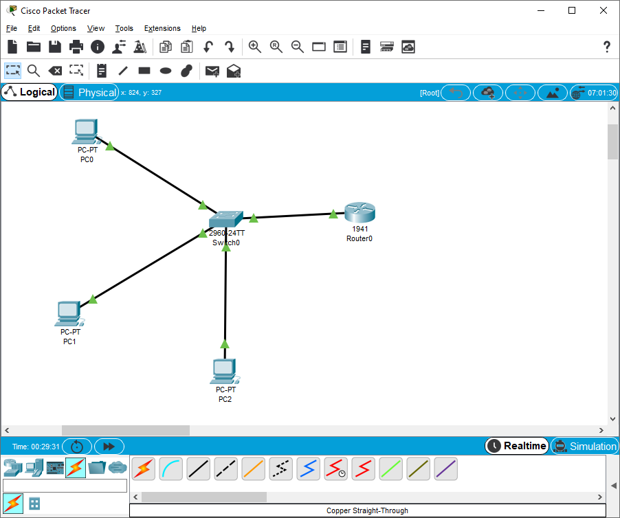

**Configure the Router 0:** 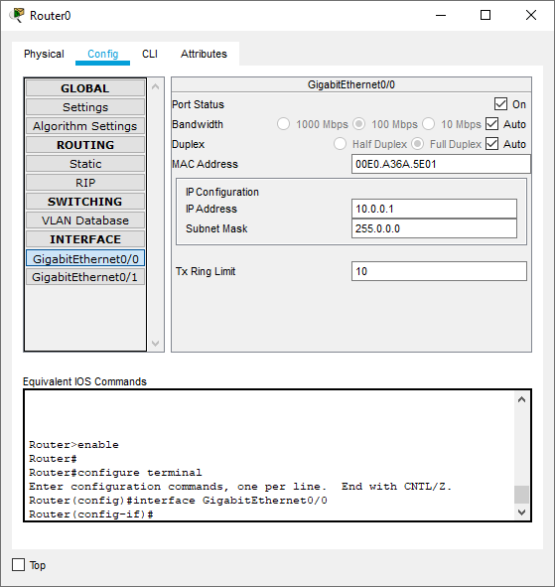

**Configure PC2:**

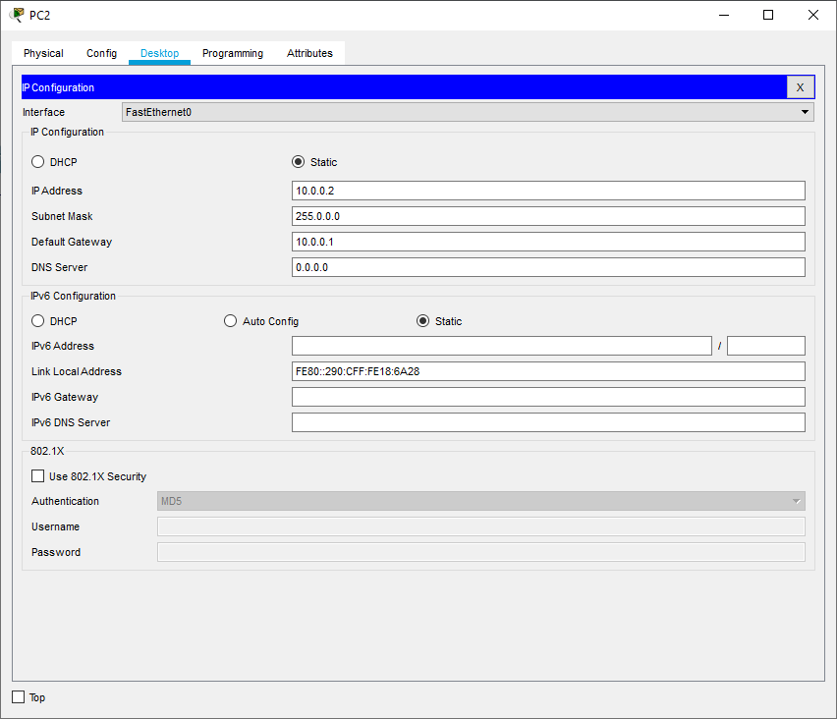

**Configure PC1:**

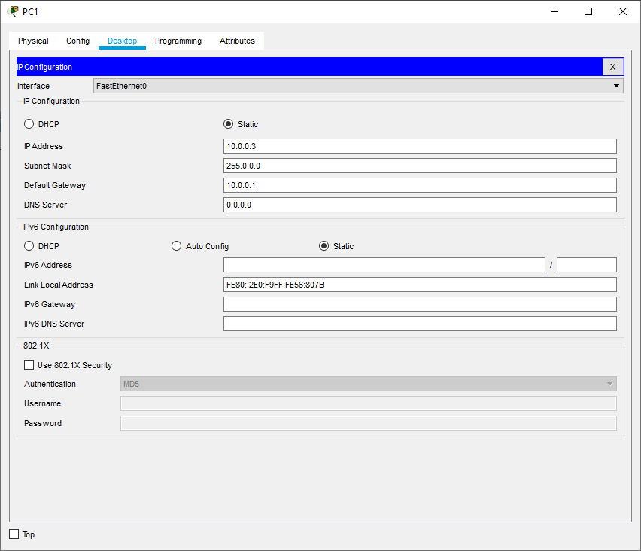

**Configure PC0:**

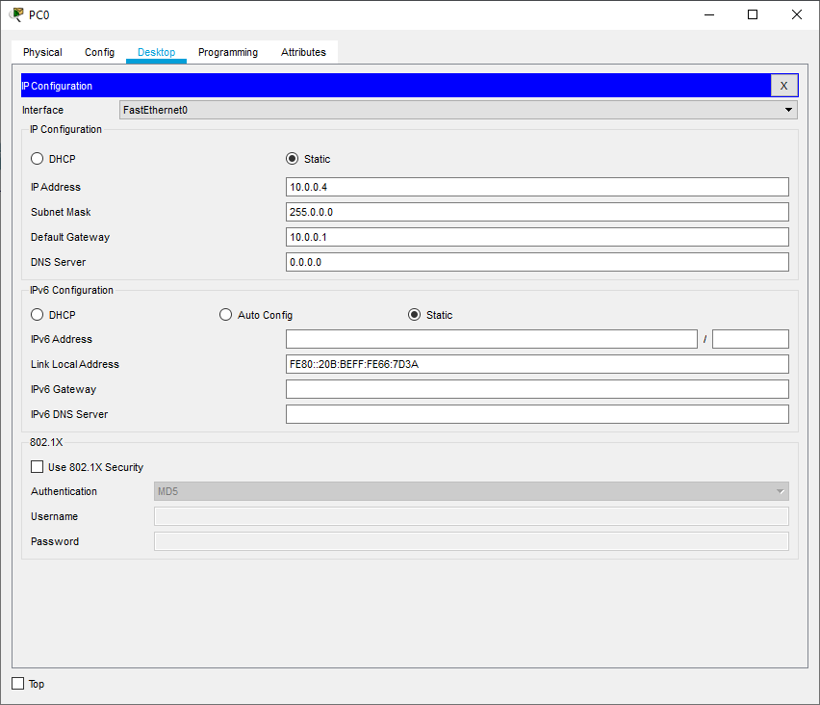

Next, we type the following commands in PC0

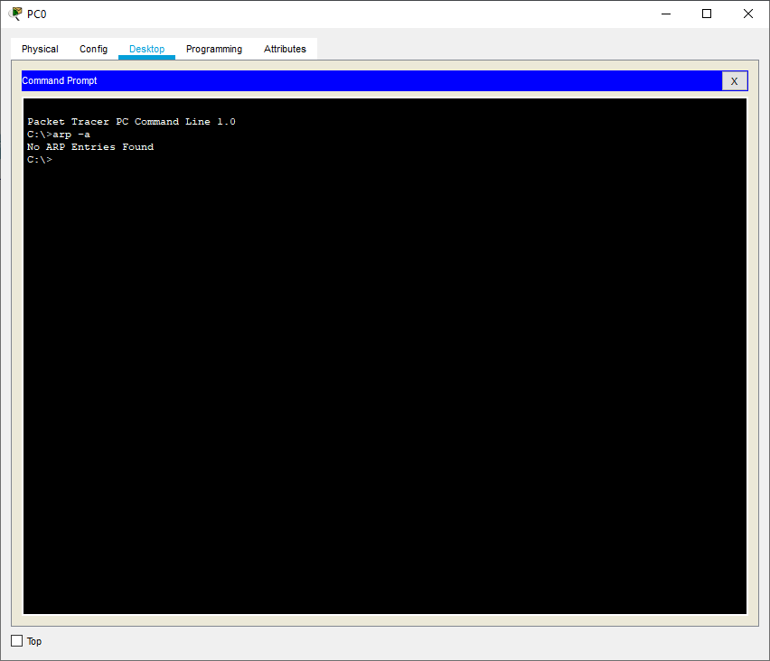

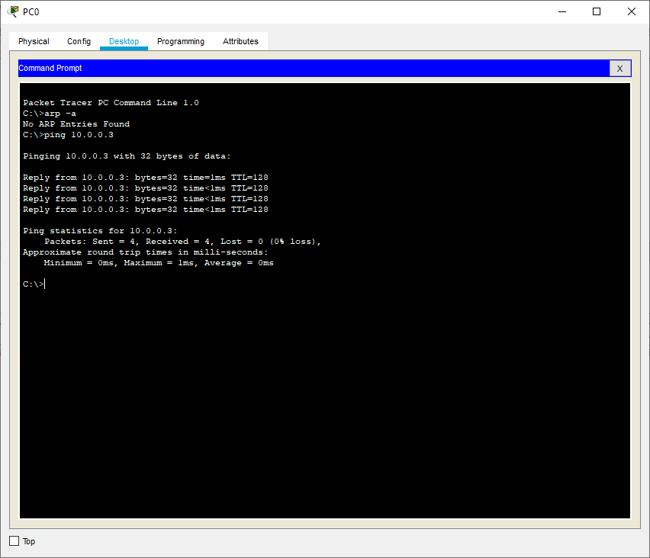

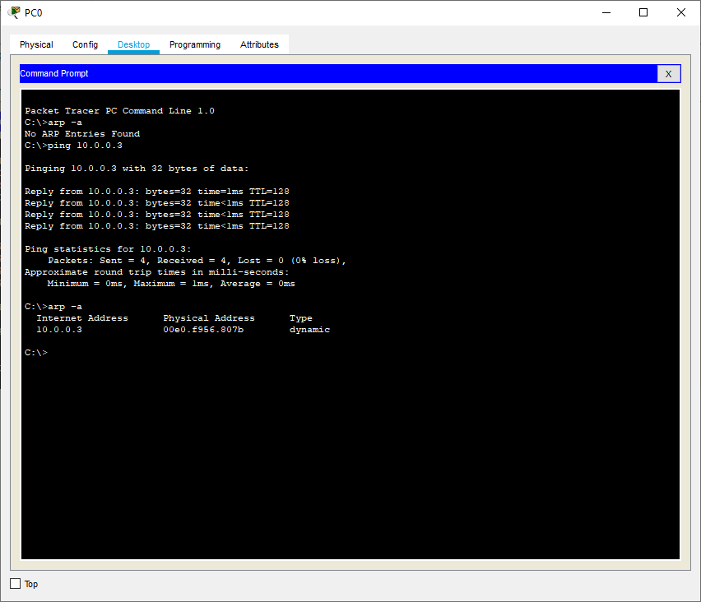

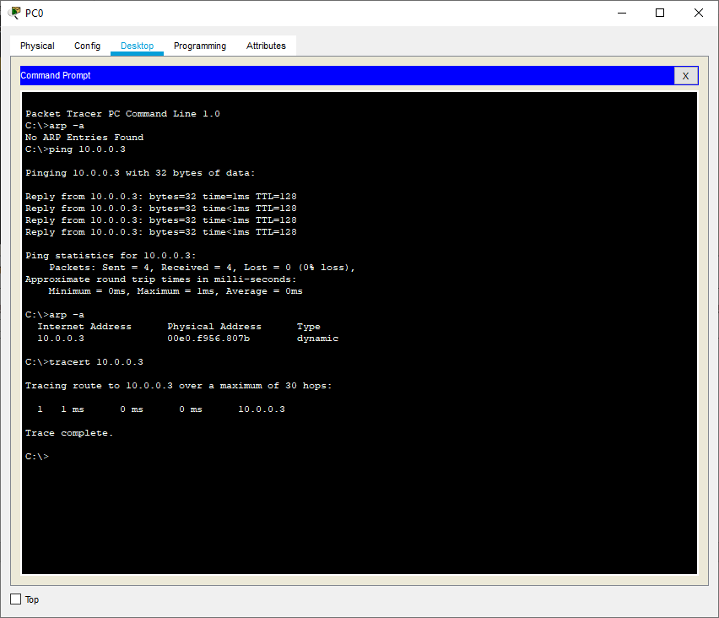

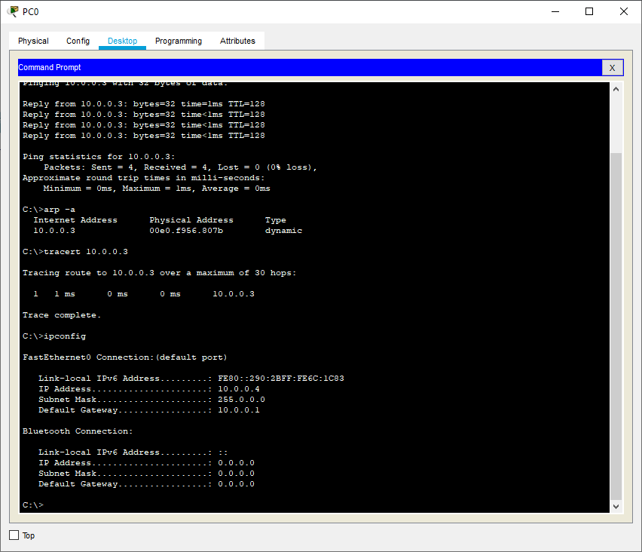

**Part d) Basic Network Troubleshooting**

Basic network troubleshooting refers to the process of identifying and resolving common issues that can arise in a computer network. Following are some essential steps and techniques for basic network troubleshooting:

1. **Identify the Problem:** Start by gathering information from the user or by observing the issue yourself. Understand what specific problem the user is facing, such as no internet access, slow connection, or inability to access certain resources.
2. **Check Physical Connections:** Ensure all network cables are securely plugged in, and network devices like routers, switches, and modems have power and functioning indicators.
3. **Restart Devices:** Sometimes, network issues can be resolved by simply restarting the network devices. Power cycle the router, modem, and any other network equipment to see if it resolves the problem.
4. **Check Network Configurations:** Verify the network settings on the computer or device experiencing the issue. Look for correct IP configurations, subnet masks, gateway addresses, and DNS server settings.
5. **Ping Test:** Use the ping command to check the connectivity between the computer and other devices on the network or the internet. For example, try pinging the router, another computer on the network, or an external website.
6. **Check for IP Conflicts**: Ensure that there are no IP address conflicts on the network. Two devices with the same IP address can cause communication problems.
7. **Firewall and Security Software**: Temporarily disable any firewall or security software to check if they are blocking network access.
8. **Update Network Drivers:** Ensure that the network interface card (NIC) drivers are up to date. Outdated drivers can lead to connectivity issues.
9. **Test Different Devices:** If possible, try connecting the problematic device to a different network or connecting a different device to the same network to see if the issue persists.
10. **Check Router and DHCP:** Verify that the router is functioning correctly and that the DHCP server is assigning IP addresses to devices on the network.
11. **Trace Route:** Use the tracert (Windows) or traceroute (macOS and Linux) command to trace the path from your computer to a remote server or website. This can help identify network hops where there might be an issue.
12. **Check for Network Outages:** Check with your Internet Service Provider (ISP) or network administrator to see if there are any known network outages or maintenance activities in your area.
13. **Use Network Troubleshooting Tools:** Network troubleshooting tools like ipconfig, ifconfig, nslookup, and netstat can provide valuable information about network configurations and connections.
14. **Check Physical Environment:** Ensure that there are no physical obstructions or interference (e.g., walls, microwave ovens) that could affect wireless network connectivity.

**Part e) Configuration of TCP/IP Protocols in Windows / Linux**

Configuring TCP/IP protocols in Windows involves setting up IP addresses, subnet masks, default gateways, and DNS server addresses.

Following steps guide us to configuring TCP/IP protocols on a Windows computer:

1. Open Network Connections: Press the Windows key + R to open the Run dialog, then type ncpa.cpl and hit Enter. This will open the "Network Connections" window.
2. Select Network Adapter: Identify the network adapter you want to configure (e.g., Ethernet or Wi-Fi). Right-click on it and select "Properties."
3. Choose Internet Protocol Version 4 (TCP/IPv4): In the "Properties" window, scroll down the list of items to find "Internet Protocol Version 4 (TCP/IPv4)." Select it and click on the "Properties" button.
4. Configure IP Address Settings:

To use a dynamic (automatic) IP address, choose the option "Obtain an IP address automatically" and "Obtain DNS server address automatically." This is usually the setting for home networks and networks with a DHCP server.

To use a static IP address, choose the option "Use the following IP address" and enter the desired IP address, subnet mask, default gateway, and preferred/alternate DNS server addresses manually. This is common for servers or when using a specific network configuration.

1. Configure Advanced IP Settings (optional):

Click on the "Advanced" button to configure additional settings.

In the "IP Settings" tab, you can add multiple IP addresses (if needed) by clicking on "Add" and specifying the address and subnet mask.

In the "DNS" tab, you can configure DNS suffixes and register connections in DNS, among other options.

The "WINS" tab is typically not required for modern networks, as WINS (Windows Internet Name Service) is used for older Windows networking.

1. Internet Protocol Version 6 (TCP/IPv6) (optional):

You can also configure IPv6 settings in a similar manner by selecting "Internet Protocol Version 6 (TCP/IPv6)" and clicking on the "Properties" button.

The default setting is usually "Obtain an IPv6 address automatically," but you can choose "Use the following IPv6 address" to enter a static IPv6 address manually.

1. Confirm and Apply Changes: Once you've made the necessary configurations, click "OK" to save the changes and close the properties window.
2. Verify Connectivity: After configuring TCP/IP protocols, test the network connectivity to ensure everything is working correctly. Try accessing websites, ping other devices on the network, or use other network-based applications to confirm that the changes have been successful.

Remember that changing network settings can disrupt your network connection temporarily. If you encounter any issues or lose connectivity, you can revert to the previous settings or use the "Obtain an IP address automatically" option to obtain settings from a DHCP server, if available.

**Part f) Networks Implementation of Drive/file sharing and printer sharing**

Implementing drive/file sharing and printer sharing in a network allows multiple users to access shared files and use shared printers efficiently. These features can be set up on both small local networks (e.g., home networks) and larger corporate networks.

Implementing drive/file sharing and printer sharing in a Windows-based network as follows:

**Set Up File Sharing:**

File sharing allows users to access files and folders stored on a central server or on individual computers across the network.

Step 1: Share Folders:

Right-click on the folder you want to share and select "Properties."

In the Properties window, go to the "Sharing" tab.

Click on "Advanced Sharing" and check the box for "Share this folder."

Assign a Share Name (also known as a "Share Name" or "Share Path") that other users will use to access the shared folder.

You can set permissions to control who can access the folder and what level of access they have (read-only, read/write, etc.).

Step 2: Access Shared Folders:

Open File Explorer on another computer connected to the network.

In the address bar, type \\<IP address or computer name of the shared folder> and press Enter.

You should see a list of shared folders on that computer. Double-click on the folder you want to access and enter the appropriate credentials if required.

**Set Up Printer Sharing:**

Printer sharing allows multiple users to print to a single printer connected to a computer on the network.

Step 1: Share the Printer:

Connect the printer to the computer you want to use as a print server (the computer that will share the printer).

Open the Control Panel and go to "Devices and Printers."

Right-click on the printer you want to share and select "Printer properties."

In the properties window, go to the "Sharing" tab.

Check the box for "Share this printer" and provide a Share Name for the printer.

Step 2: Connect to the Shared Printer:

On other computers connected to the network, open the Control Panel and go to "Devices and Printers."

Click on "Add a printer" and then select "Add a network, wireless, or Bluetooth printer."

The shared printer should appear in the list. Select it and follow the on-screen instructions to install the printer driver and connect to the shared printer.

**Practical 3**

**IPv4 Addressing and Subnetting**

Aim:

1. Given an IP address and network mask, determine other information about the IP address such as
2. Network address
3. Network broadcast address
4. Total number of host bits
5. Number of hosts
6. Given an IP address and network mask, determine other information about the IP address such as:
7. The subnet address of this subnet
8. The broadcast address of this subnet
9. The range of host addresses for this subnet
10. The maximum number of subnets for this subnet mask
11. The number of hosts for each subnet
12. The number of subnet bits
13. The number of this subnet

**Part a)** An address in a block is given as 180.8.17.9. Find the number of addresses in the block, the first address, and the last address

**Solution:**

The given address is a Class B address therefore n= 16

1. **No of addresses:**

N = 2 32-n

= 2 32-16

= 216

= 65536

Therefore, the number of addresses are = 65536 addresses

1. **First address:**

For class B address netid = 16 Therefore network mask is 255.255.0.0

To find the first address we logically AND the given address with the network mask

| Given address | 180 | 8 | 17 | 9 |
| --- | --- | --- | --- | --- |
| Network mask | 255 | 255 | 0 | 0 |
| AND  operation | 180 | 8 | 0 | 0 |

Therefore, the first address is 180.8.0.0

1. **Last address:**

To find the last address we logically OR the given address with the COMPLEMENT of the network mask

Network mask = 255.255.0.0

| Network mask | 255 | 255 | 0 | 0 |
| --- | --- | --- | --- | --- |
| Complement of mask | 0 | 0 | 255 | 255 |

| Given address | 180 | 8 | 17 | 9 |
| --- | --- | --- | --- | --- |
| Complement of mask | 0 | 0 | 255 | 255 |
| OR operation | 180 | 8 | 255 | 255 |

Therefore, the last address is 180.8.255.255

Hence, we conclude that

1. Network address: The first address is the Network Address 180.8.0.0
2. Network broadcast address: The last address is the Network broadcast address 180.8.255.255
3. Total number of host bits: 16
4. Number of hosts: 65534 (65536 – 2)

**Part b)** An organization is granted the block 130.34.12.64/26. The organization needs four sub networks, each with an equal number of hosts. Design the sub networks and find the information about each network.

Solution:

The given address is address of type classless addressing with n= 26

1. **No of addresses:**

N = 232-n

= 232-26

= 26

= 64

Therefore, the number of addresses is = 64 addresses

1. **First address:**

For the given case n = 26

Therefore, network mask is 255.255.255.192

To find the first address we logically AND the given address with the network mask

| Given address | 130 | 34 | 12 | 64 |
| --- | --- | --- | --- | --- |
| Network mask | 255 | 255 | 255 | 192 |
| AND  operation | 130 | 34 | 12 | 64 |

Therefore the first address is 130.34.12.64

1. **Last address:**

Network mask is 255.255.255.192

| Network mask | 255 | 255 | 255 | 192 |
| --- | --- | --- | --- | --- |
| Complement of mask | 0 | 0 | 0 | 63 |

To find the last address we logically OR the given address with the Complement of the network mask

| Given address | 130 | 34 | 12 | 64 |
| --- | --- | --- | --- | --- |
| Network mask | 0 | 0 | 0 | 63 |
| OR  operation | 130 | 34 | 12 | 127 |

Therefore the last address is 130.34.12.127

1. **Creating sub-networks:**

In this case we need to create 4 sub-networks with equal number of hosts

Total number of hosts N = 64

Therefore, number of hosts in each sub-network NSUB = 16

We calculate the sub-netid for each network as follows

nSUB= n + log2(N/ NSUB)

= 26 + log2(64/16)

= 28

Therefore, the given sub-networks are

| Sub-network | First address | Last address |
| --- | --- | --- |
| 1 | 130.34.12.64 | 130.34.12.79 |
| 2 | 130.34.12.80 | 130.34.12.95 |
| 3 | 130.34.12.96 | 130.34.12.111 |
| 4 | 130.34.12.112 | 130.34.12.127 |

* 1. The subnet address of this subnet: The First address of each subnet
  2. The broadcast address of this subnet: The Last address of each subnet
  3. The range of host addresses for this subnet: Shown in the above table
  4. The maximum number of subnets for this subnet mask: 4
  5. The number of hosts for each subnet: 14
  6. The number of subnet bits: 28
  7. The number of this subnet: Mentioned in the above table

**Practical 4**

**Designing and configuring a network topology**

**Aim:** Configure IP static routing

**Theory:**

1. Static routing method is most trusted by a router.
2. Static routing is not really a routing protocol.
3. Static routes do not dynamically adapt to network changes, are not particularly scalable, and require manual updating to reflect changes.

Static routing has the following advantages

1. There is no bandwidth usage between routers, which means you could possibly save money on WAN links.
2. There is no overhead on the router CPU, which means you could possibly buy a cheaper router than you would use if you were using dynamic routing.
3. It adds security because the administrator can choose to allow routing access to certain networks only.

Static routing has the following disadvantages

1. Static routes don’t dynamically adapt to network change.
2. If a network is added to the internetwork, the administrator has to add a route to it on all routers—by hand.
3. It’s not feasible in large networks because maintaining it would be a full- time job in itself.
4. With static routing, as your network grows, it can be difficult just keep adding static routes makes sure everybody can still get everything.
5. The administrator must really understand the internetwork and how each router is connected in order to configure routes correctly.

**There are two different styles to configure an “ip route” command:**

1. Using a next hop IP address
2. Using an outgoing interface

Consider the following network topology

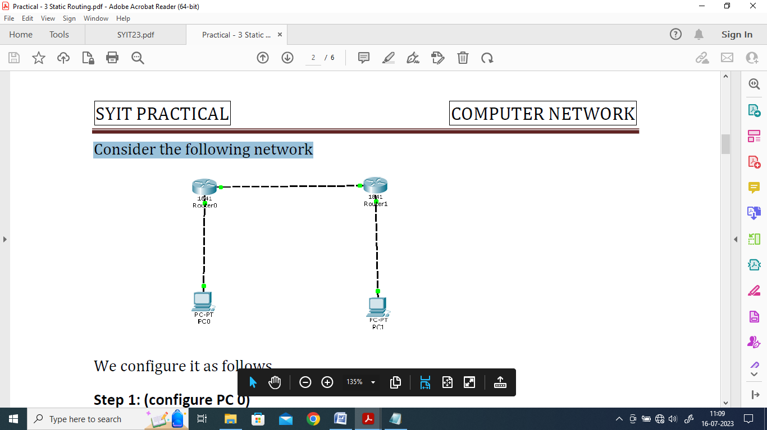

We use the following IP addresses for hosts and Routers

|  | Interface | IP address | Subnet Mask | Gateway |
| --- | --- | --- | --- | --- |
| PC0 |  | 10.0.0.2 | 255.0.0.0 | 10.0.0.1 |
| PC1 | 30.0.0.2 | 30.0.0.1 |
| Router 0 | FastEthernet 0/0 | 10.0.0.1 |  |
|  | FastEthernet 0/1 | 20.0.0.1 |
| Router 1 | FastEthernet 0/0 | 20.0.0.2 |
|  | FastEthernet 0/1 | 30.0.0.1 |

We configure the given topology using Cisco Packet tracer as follows

Step 1: Configuring PC 0

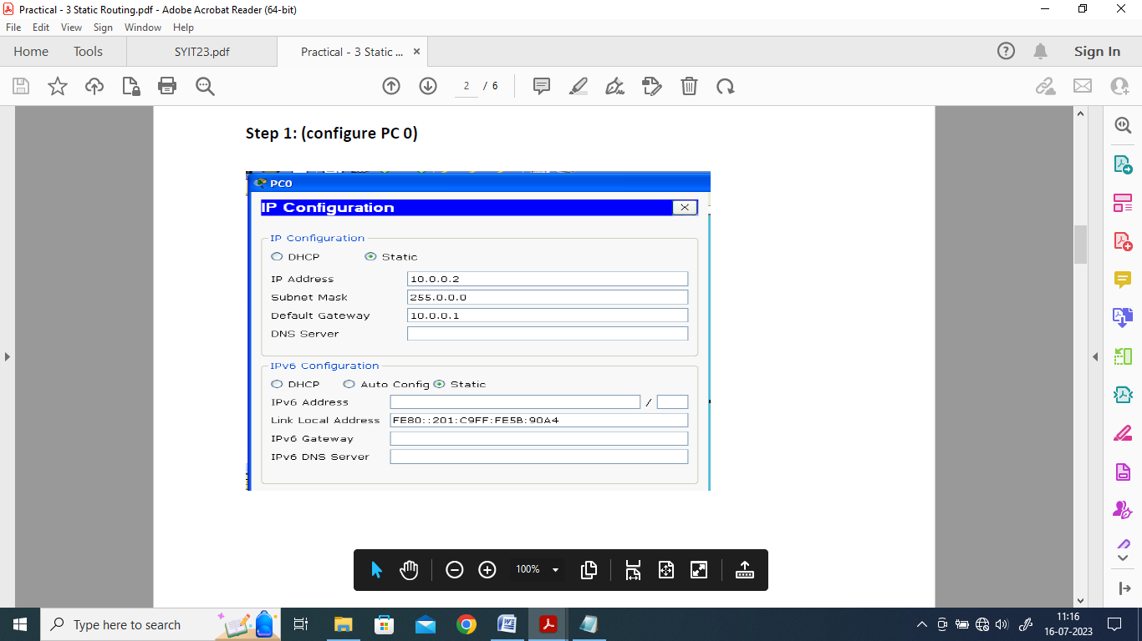

Step 2: Configuring PC 1

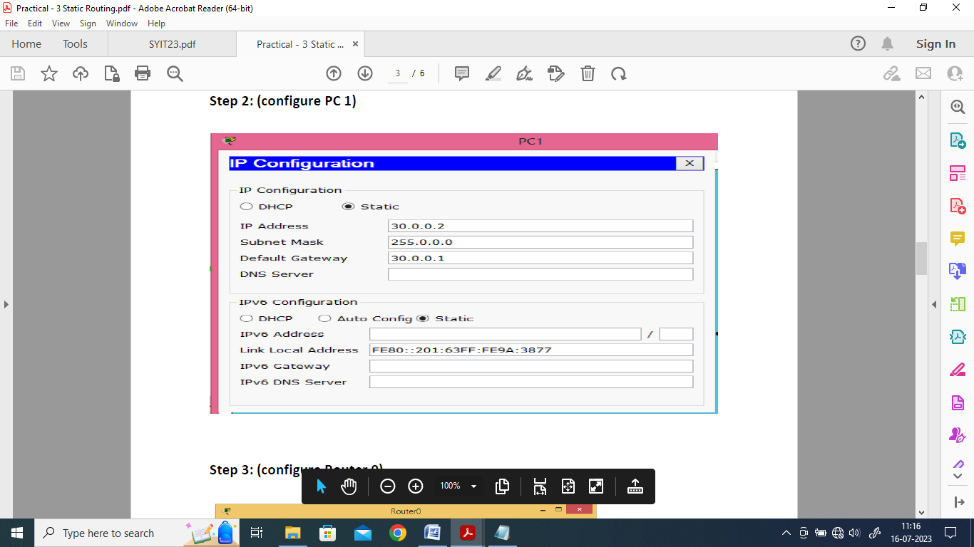

Step 3: Configuring Router 0

Interface: FastEthernet0/1

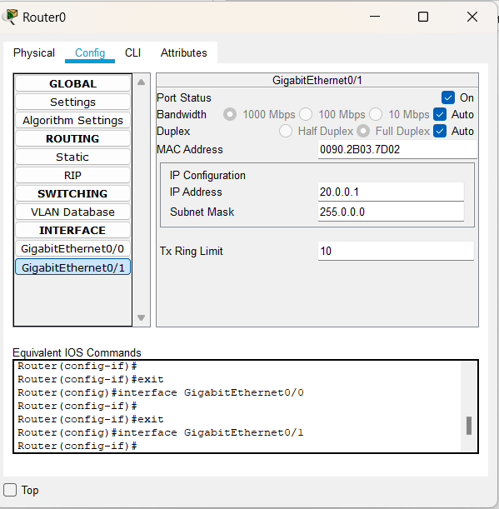

Interface: FastEthernet0/0

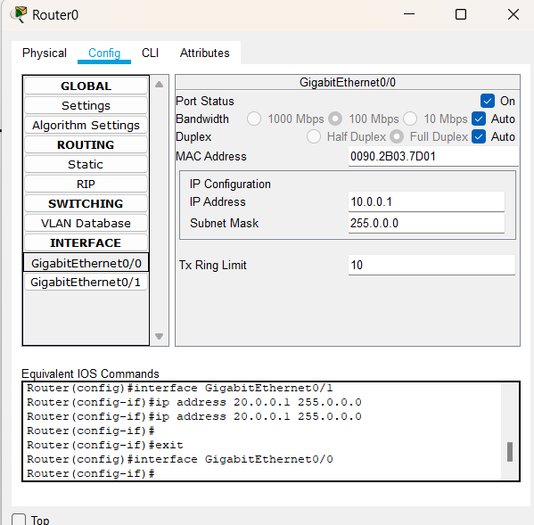

Step 4: Configure Router 1

Interface: FastEthernet0/0

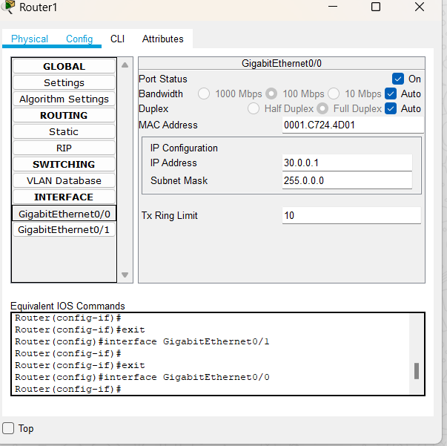

Interface: FastEthernet0/1

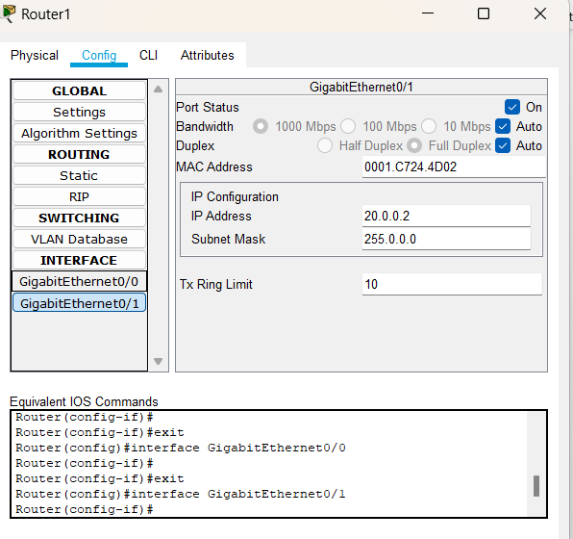

Step 5: Setting the Routing path in each Router through Static Routing

Step 5a) For Router 0

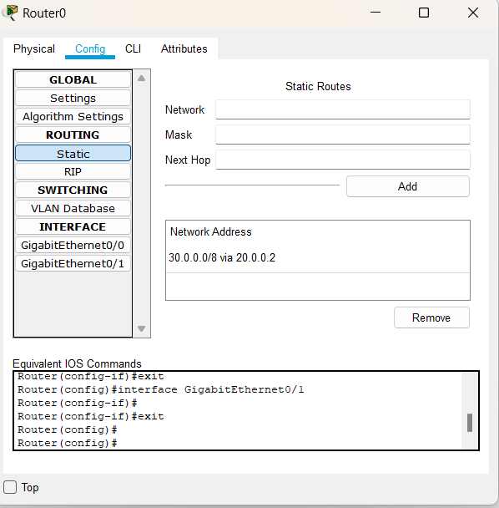

Step 5b) For Router 1

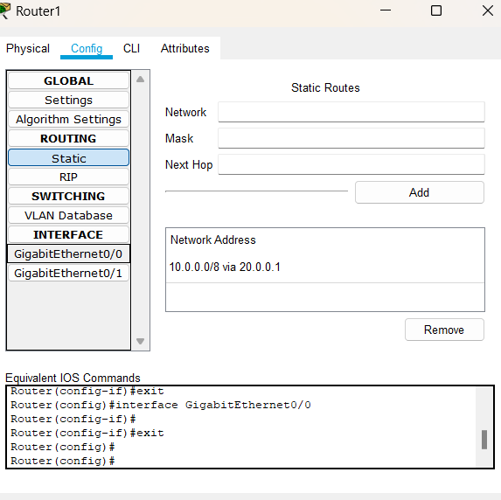

Step 6: Verifying the Connectivity using the Ping command

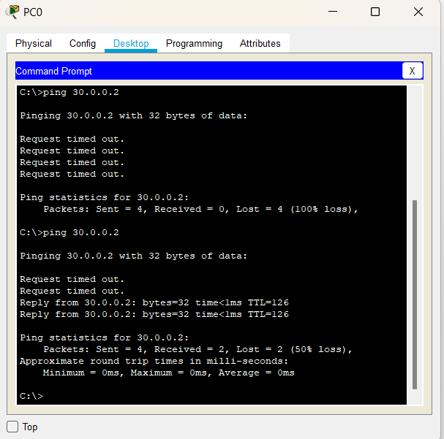

**Practical 5**

**Configure IP routing using RIP**

**Aim:** Configure IP routing using Routing Information Protocol (RIP)

**Theory:**

RIP (Routing Information Protocol) is a standardized Distance Vector protocol, designed for use on smaller networks. RIP was one of the first true Distance Vector routing protocols, and is supported on a wide variety of systems. RIP adheres to the following Distance Vector characteristics:

• RIP sends out periodic routing updates (every 30 seconds)

• RIP sends out the full routing table every periodic update

• RIP uses a form of distance as its metric (in this case, hopcount)

• RIP uses the Bellman-Ford Distance Vector algorithm to determine the best “path” to a particular destination Other characteristics of RIP include:

• RIP supports IP and IPX routing.

• RIP utilizes UDP port 520 • RIP routes have an administrative distance of 120.

• RIP has a maximum hopcount of 15 hops. Any network that is 16 hops away or more is considered unreachable to RIP, thus the maximum diameter of the network is 15 hops. A metric of 16 hops in RIP is considered a poison route or infinity metric.

We study the RIP protocol using the following network

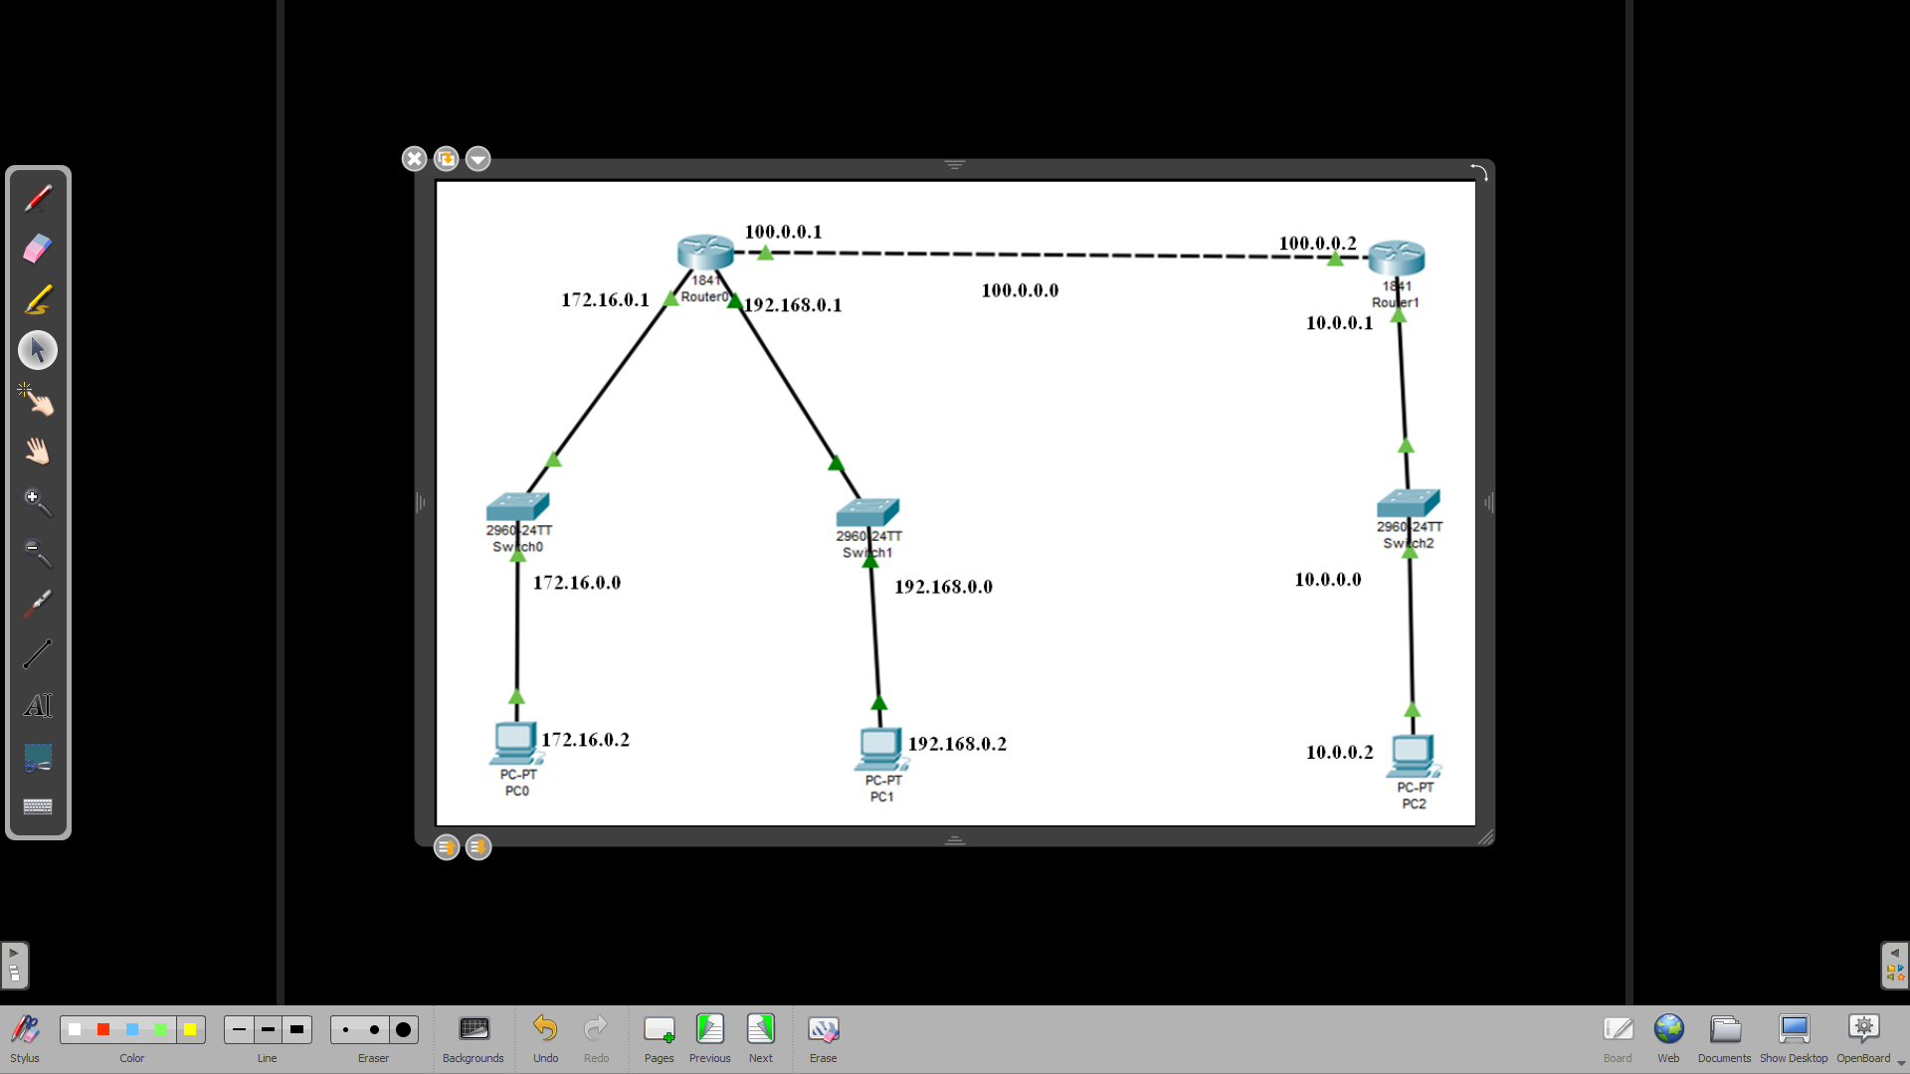

By Default Routers have 2-interfaces in most of the cases, but in our case we need 3-interfacces for Router 0, hence we need to add one interface in Router 0

Now we configure the PC’s and Routers as follows

**Step 1: Configuring PC0**

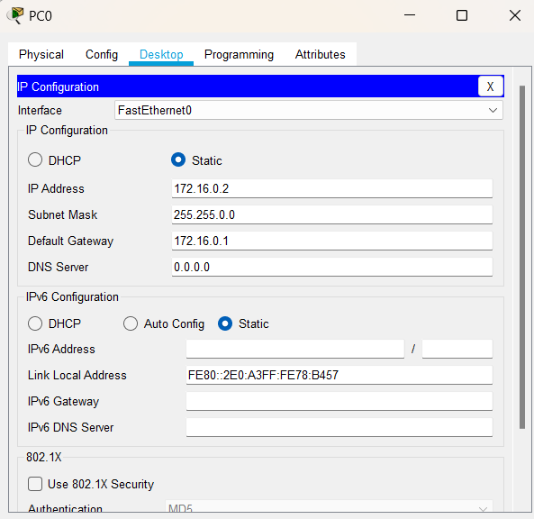

**Step 2: Configuring PC1**

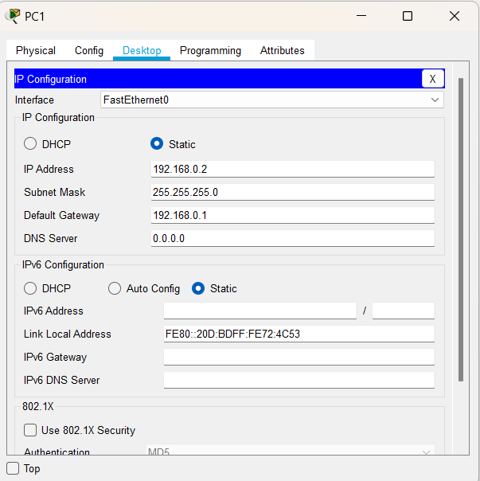

**Step 3: Configuring PC2PC2**

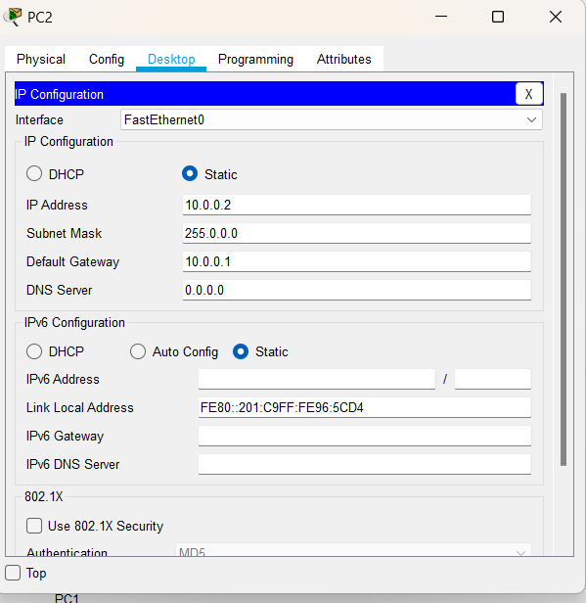

**Step 4: (configure Router 0)**

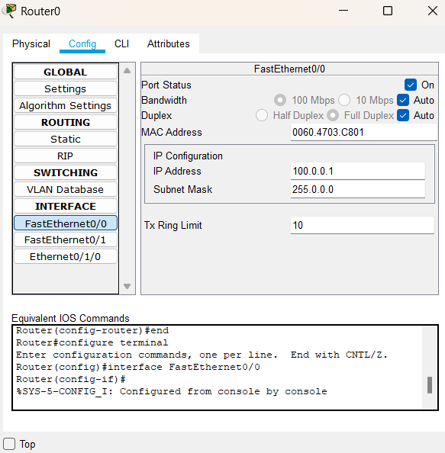

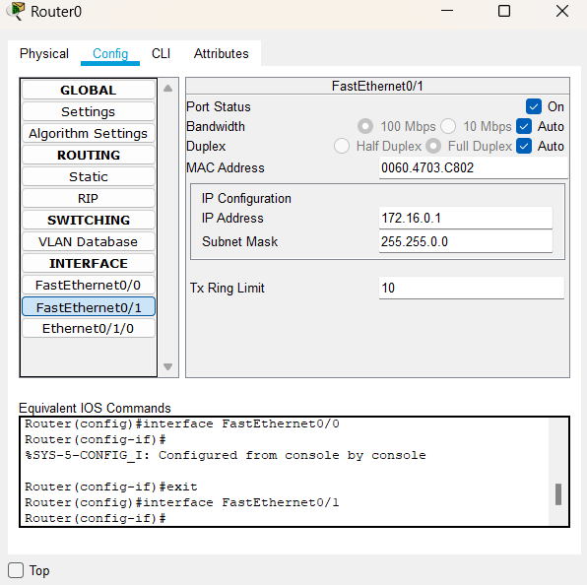

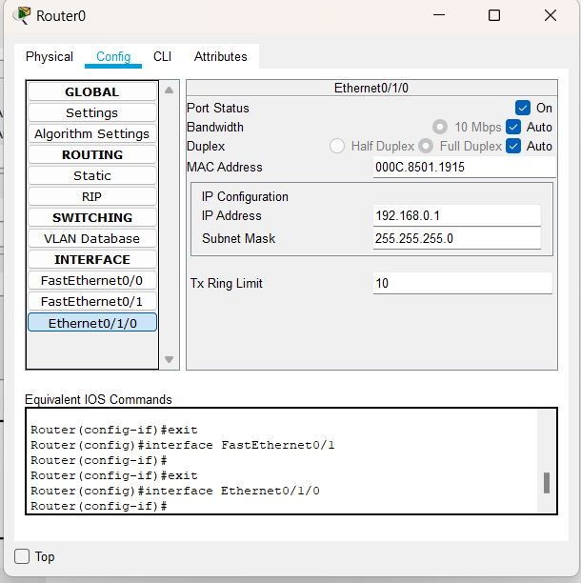

**Step 5: (configure Router 1)**

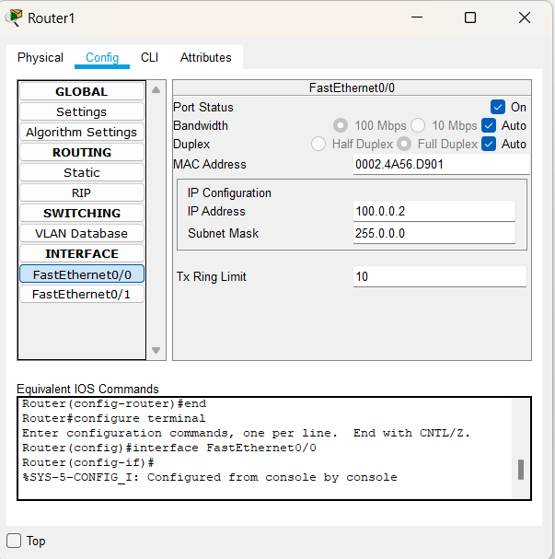

Now we configure the routing table for both the routers

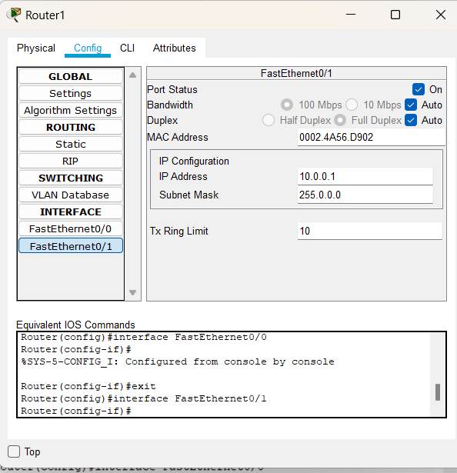

**Routing table for Router 0**

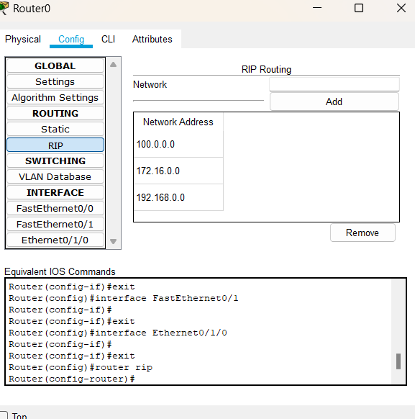

**Routing table for Router 1**

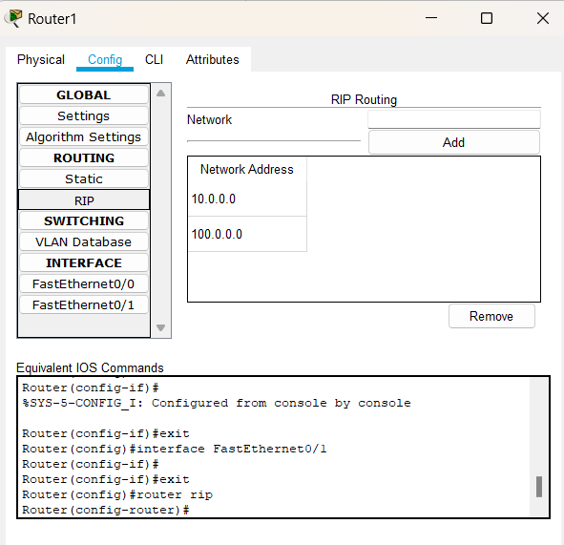

Now we use the ping command to check the working

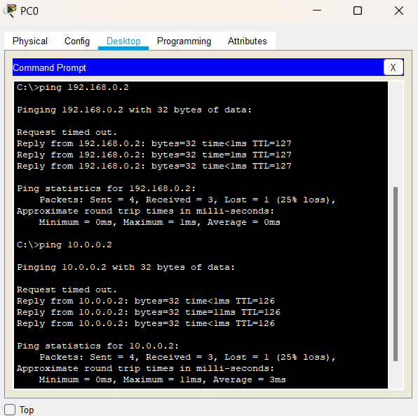

**Practical 6**

**Configuring Simple and multi-area OSPF**

**Aim:** Configuring Simple and multi-area OSPF

**Theory:**

Open shortest path first (OSPF) is a link-state routing protocol that is used to find the best path between the source and the destination router using its own shortest path first (SPF) algorithm. A link-state routing protocol is a protocol that uses the concept of triggered updates, i.e., if there is a change observed in the learned routing table then the updates are triggered only, not like the distance-vector routing protocol where the routing table is exchanged at a period of time.

Open shortest path first (OSPF) is developed by Internet Engineering Task Force (IETF) as one of the Interior Gateway Protocol (IGP), i.e., the protocol which aims at moving the packet within a large autonomous system or routing domain.

OSPF advantages –

1. Both IPv4 and IPv6 routed protocols
2. Load balancing with equal-cost routes for the same destination
3. Unlimited hop counts
4. Trigger updates for fast convergence
5. A loop-free topology using SPF algorithm
6. Run-on most routers
7. Classless protocol

There are some disadvantages of OSPF

1. It requires an extra CPU process to run the SPF algorithm
2. Requiring more RAM to store adjacency topology, and
3. Being more complex to set up and hard to troubleshoot

**Part a) Simple OSPF**

We use the following topology for the present case

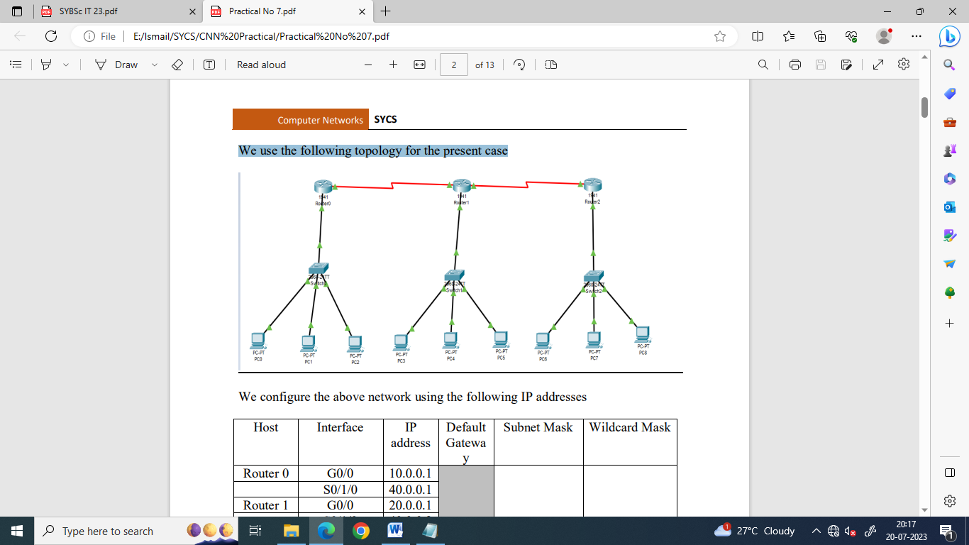

We configure the above network using the following IP addresses

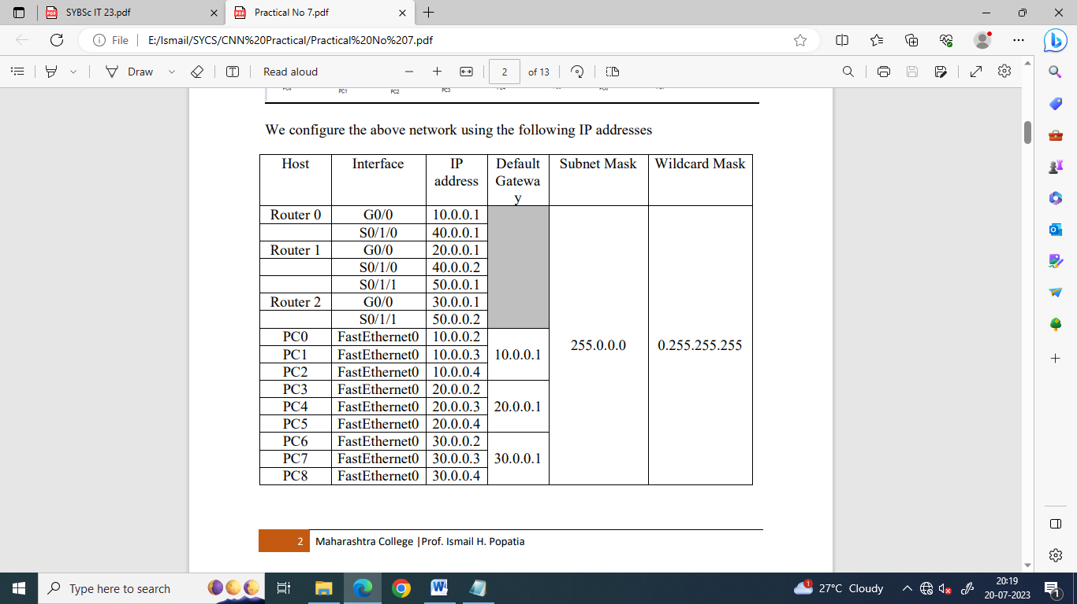

We need to add a Serial Interface in each Router, it is done as follows

Configuring PC0:

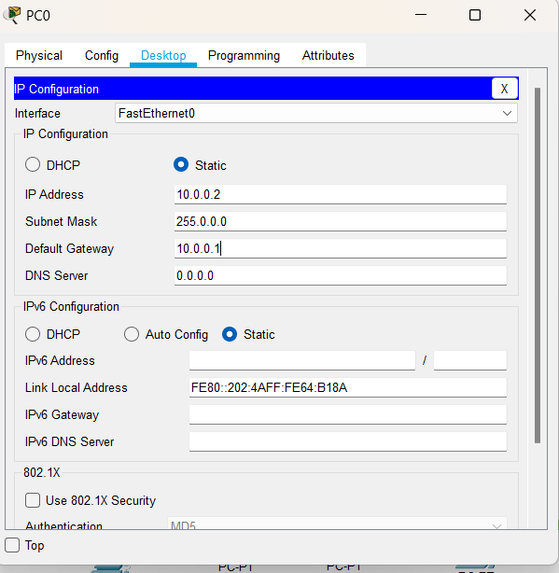

Configuring PC1:

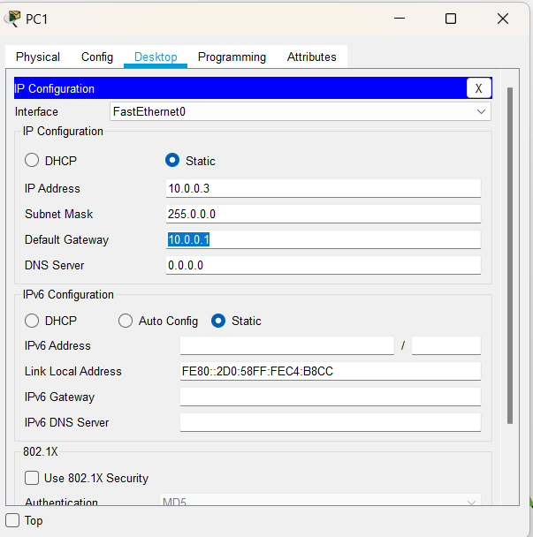

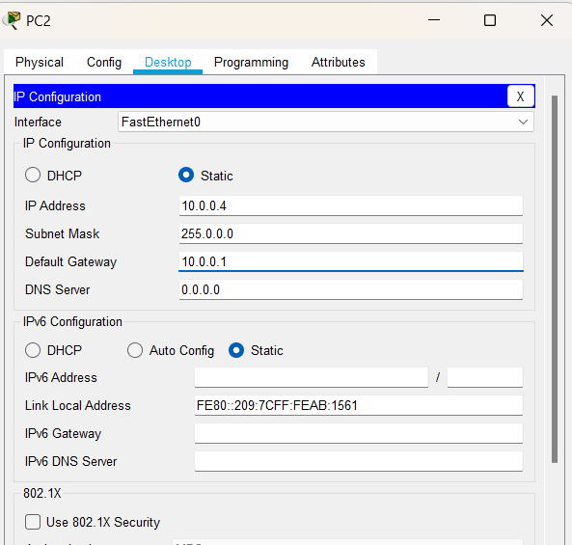

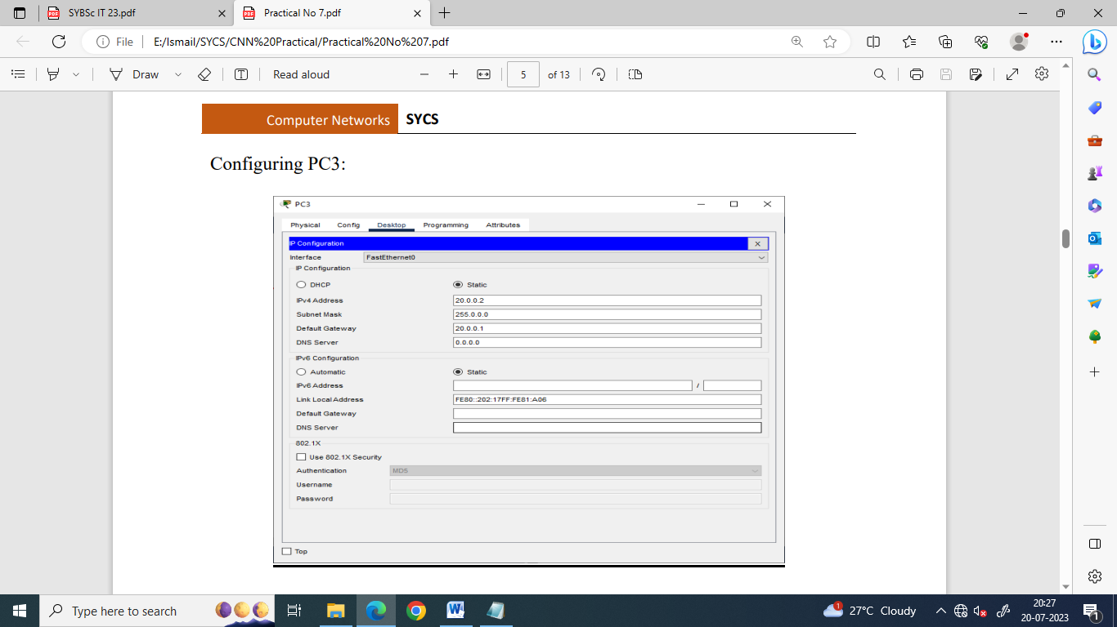

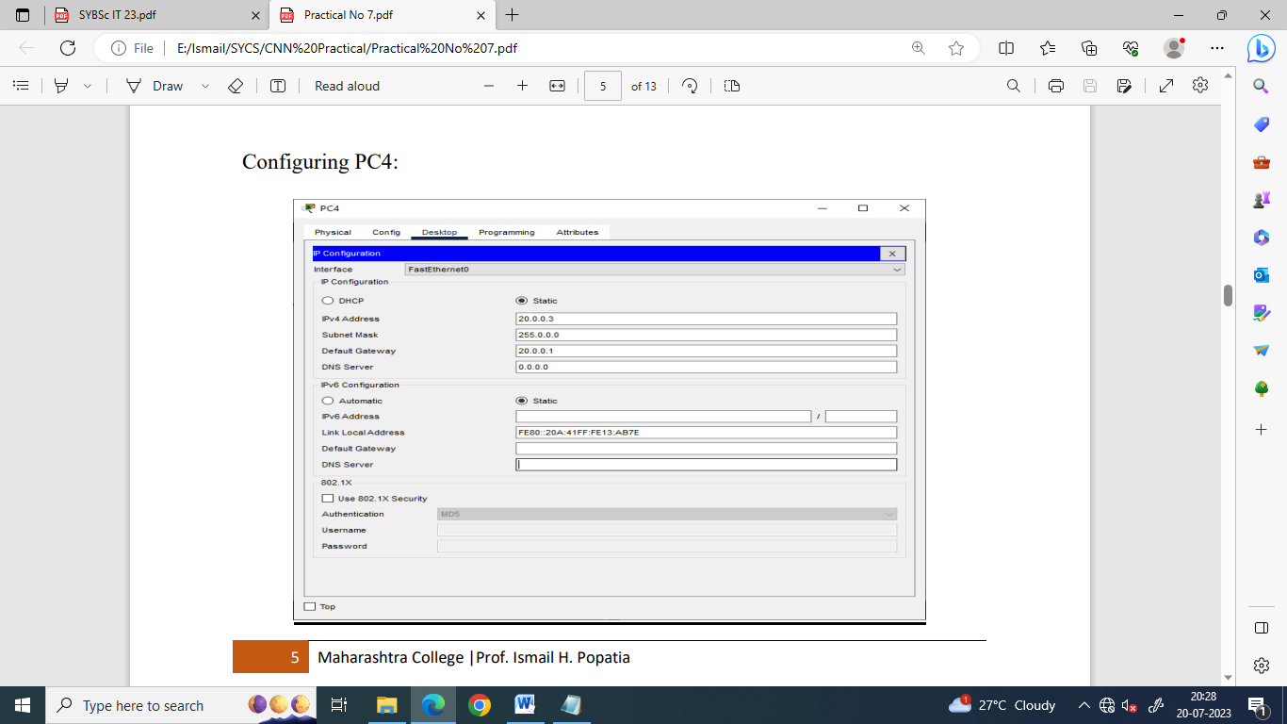

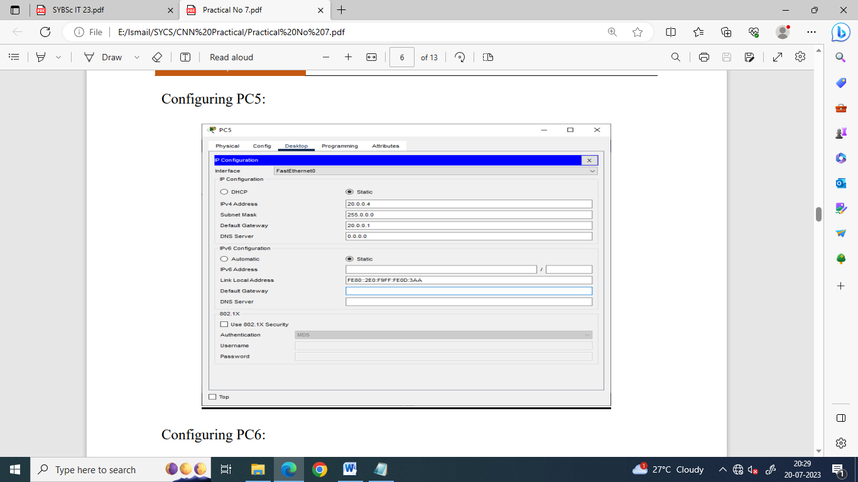

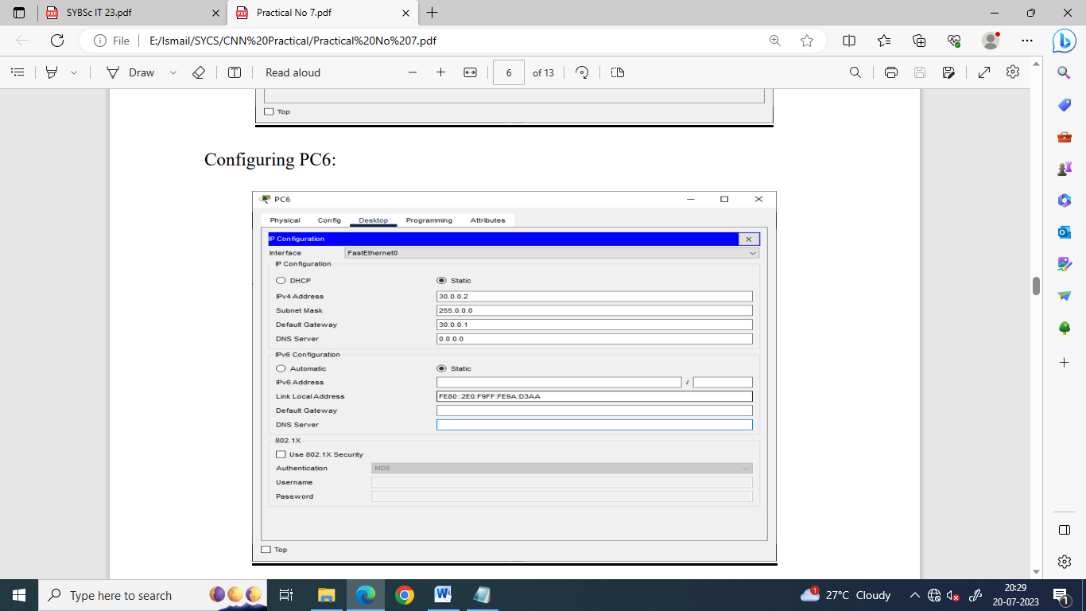

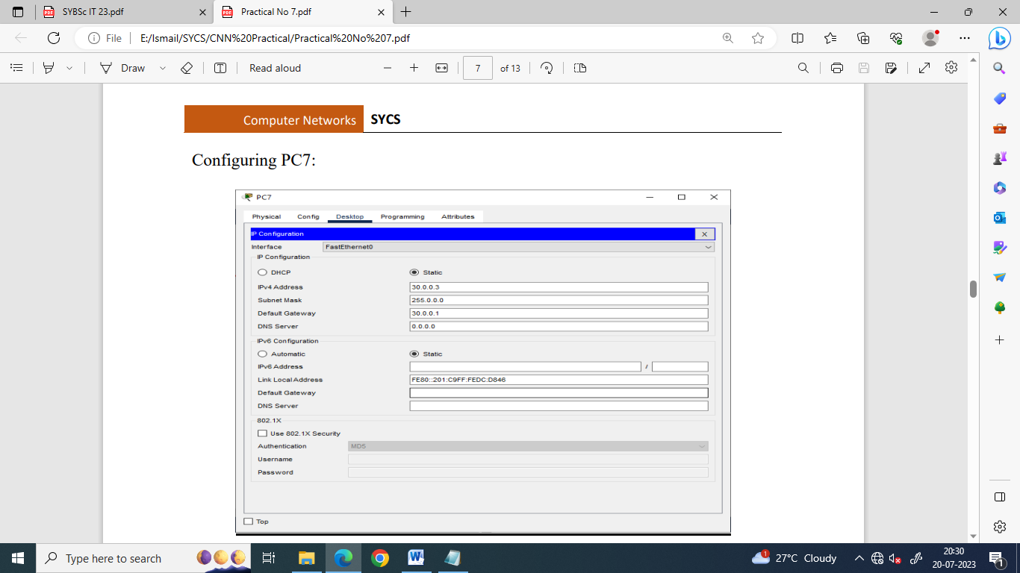

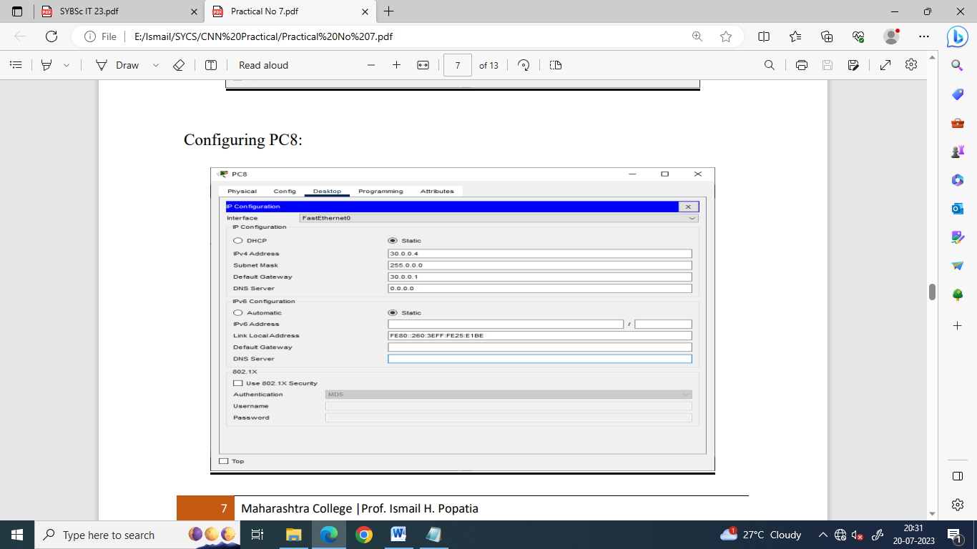

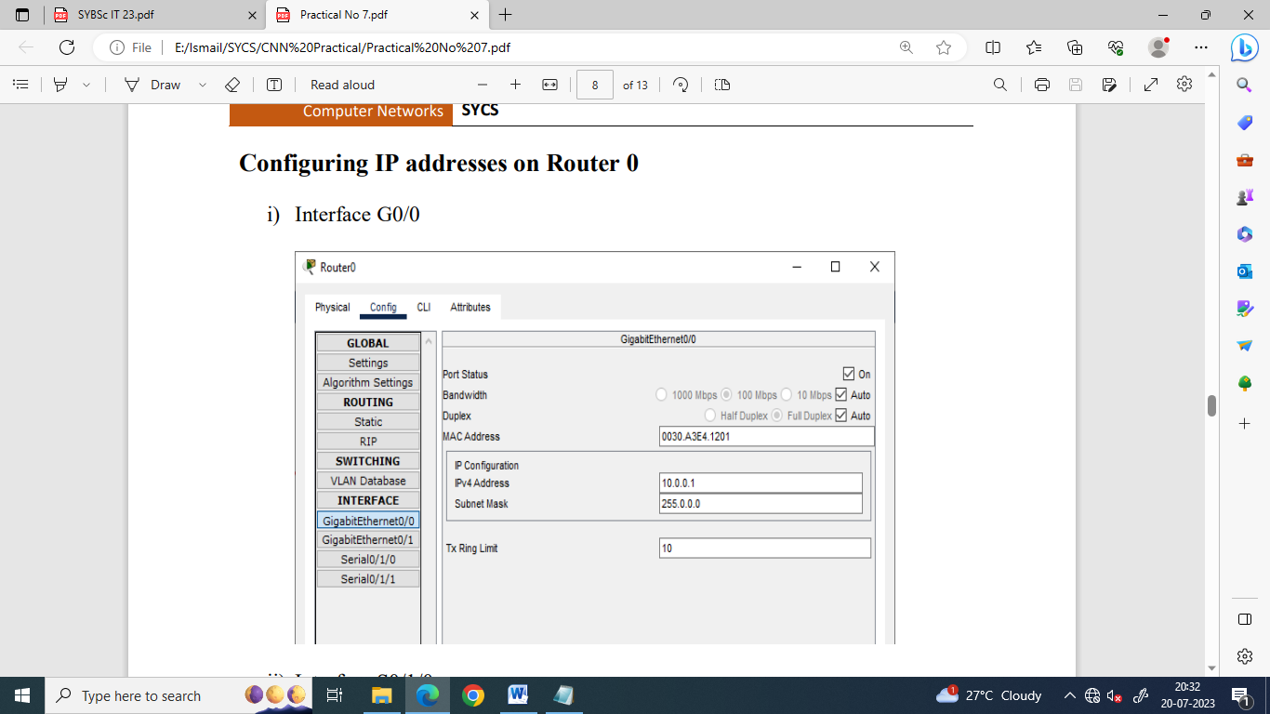

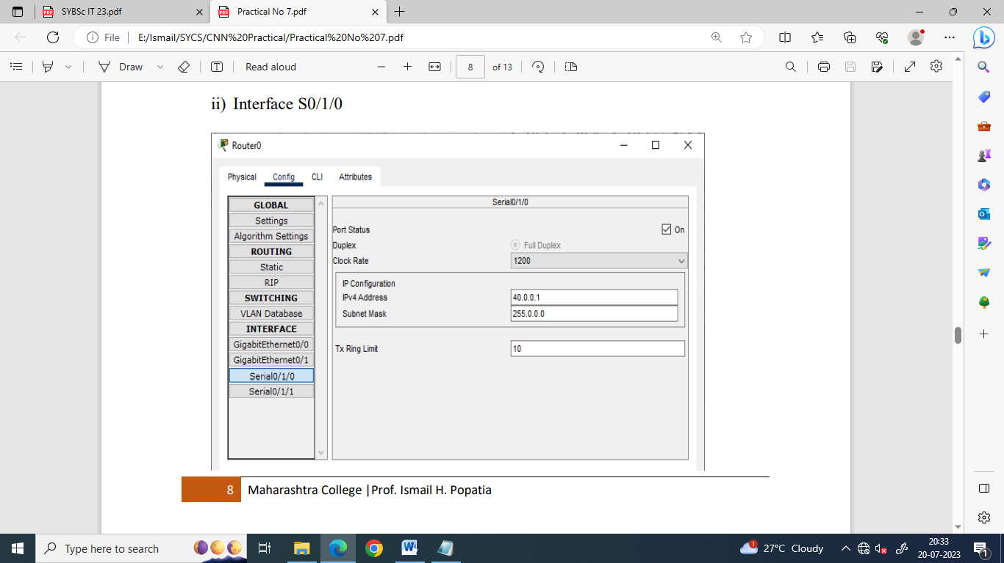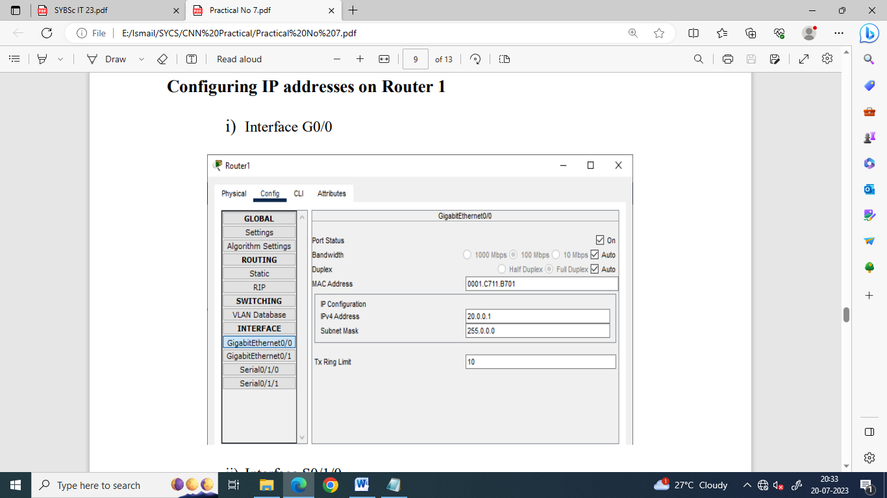

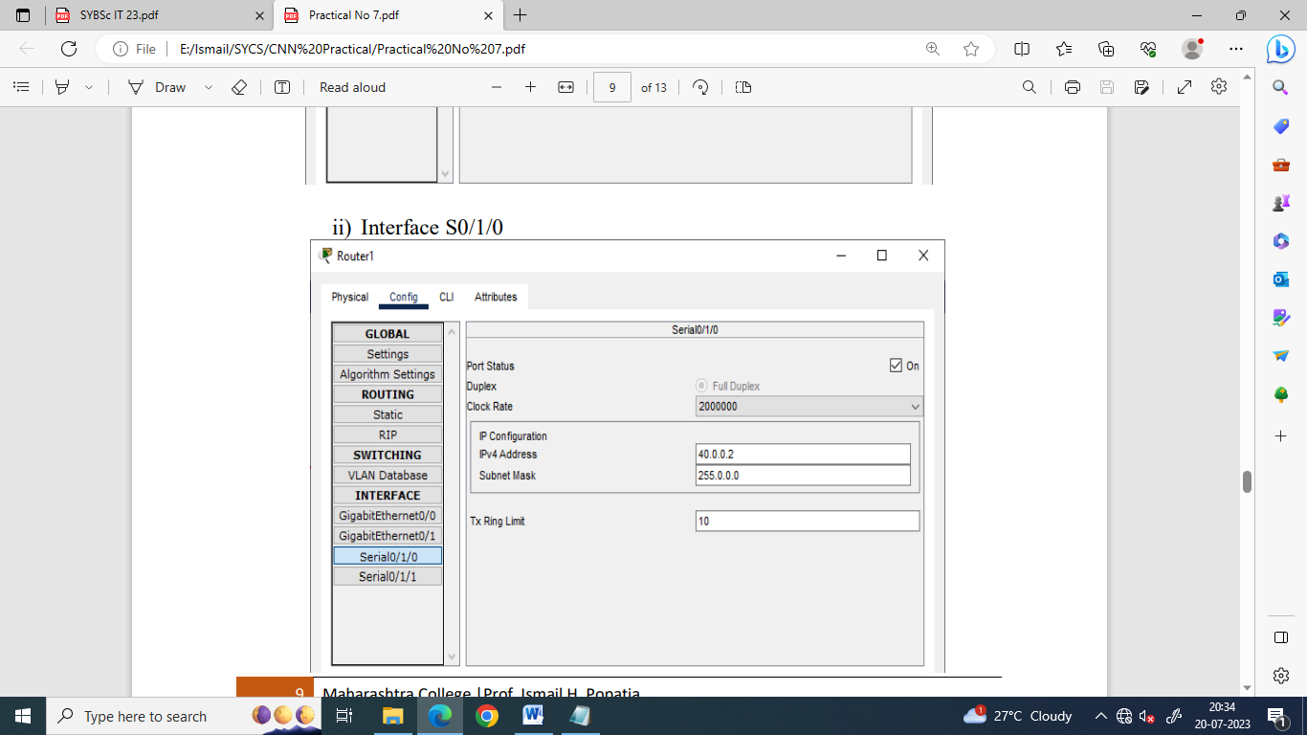

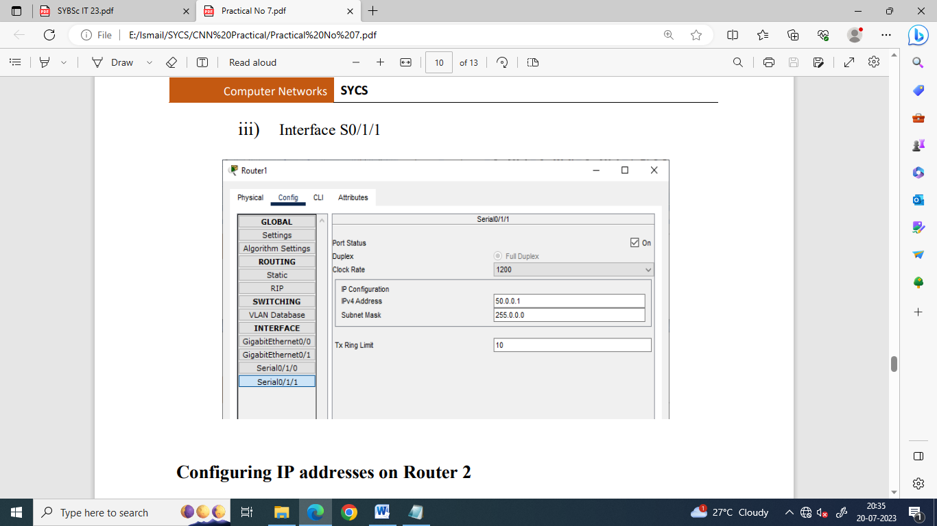

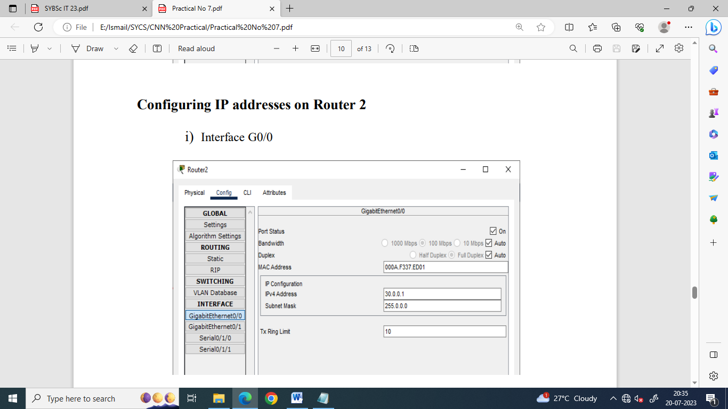

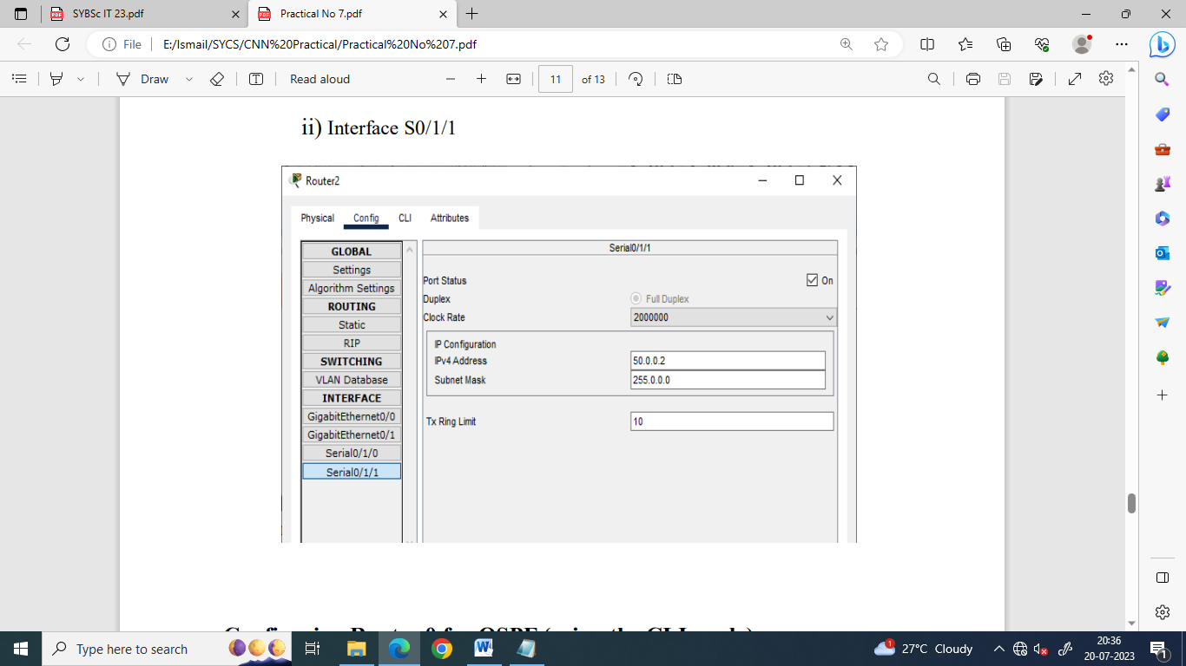

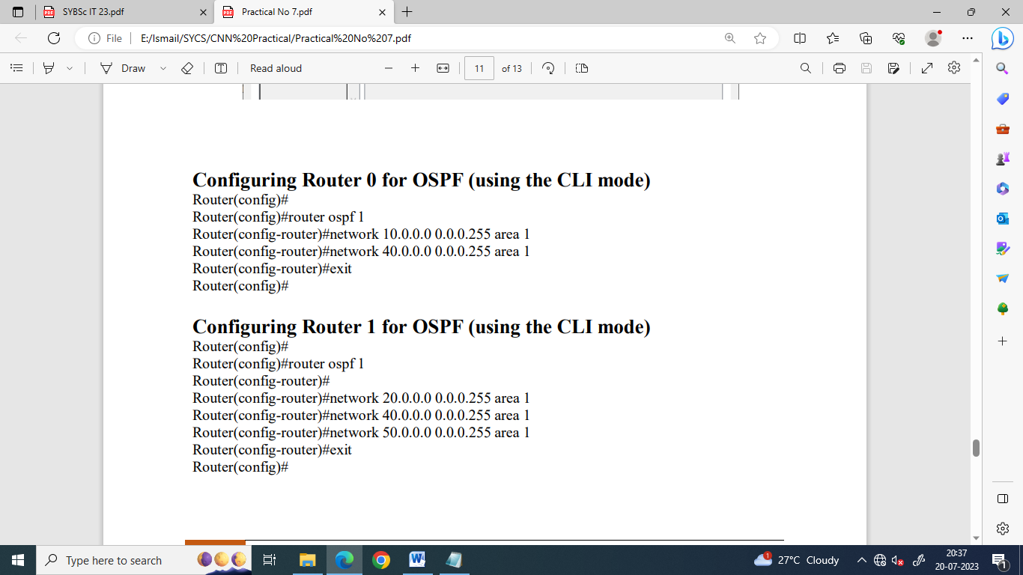

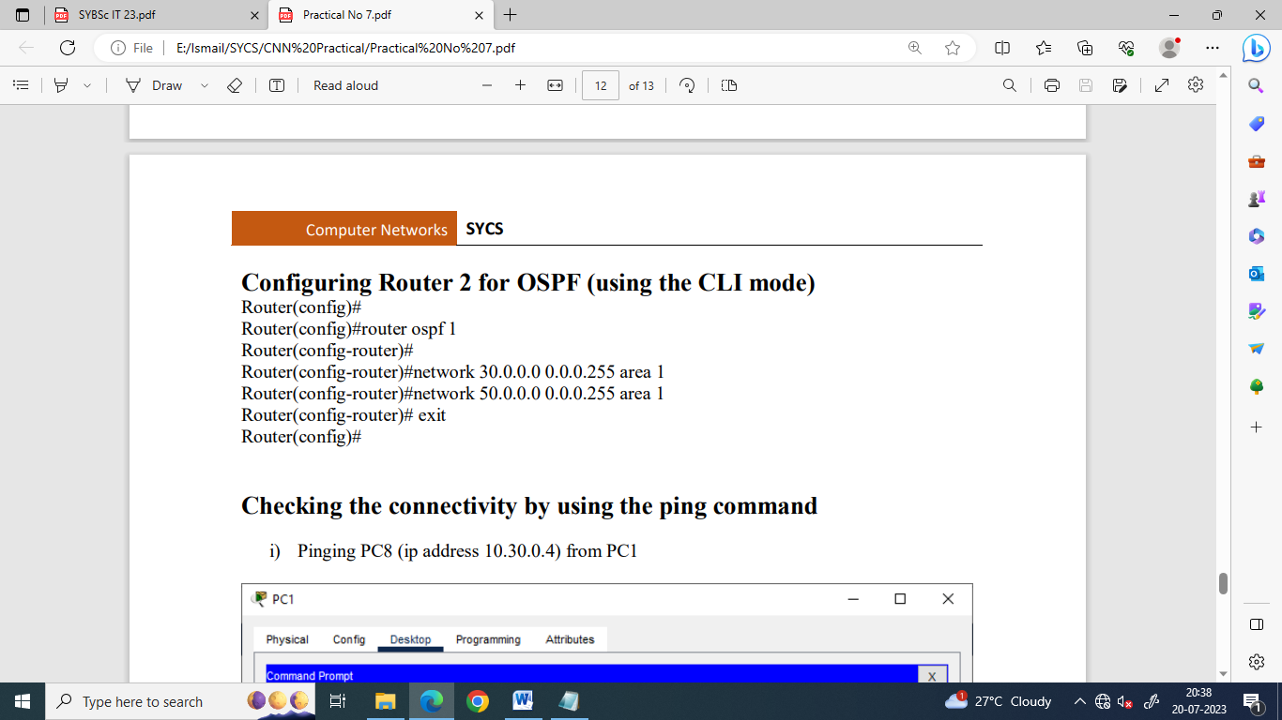

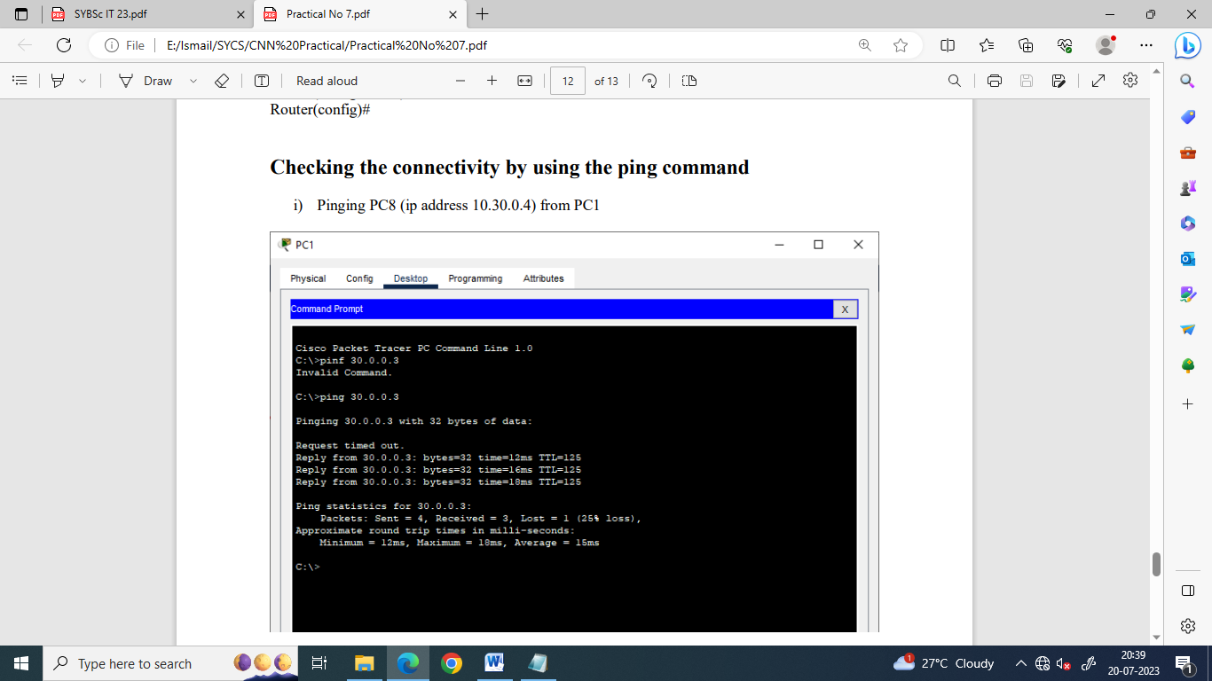

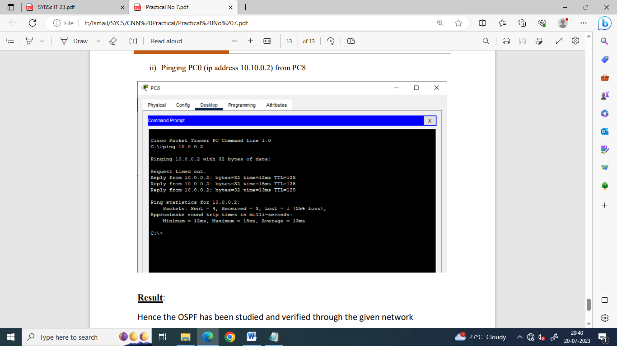

**Part b) Multi-area OSPF**

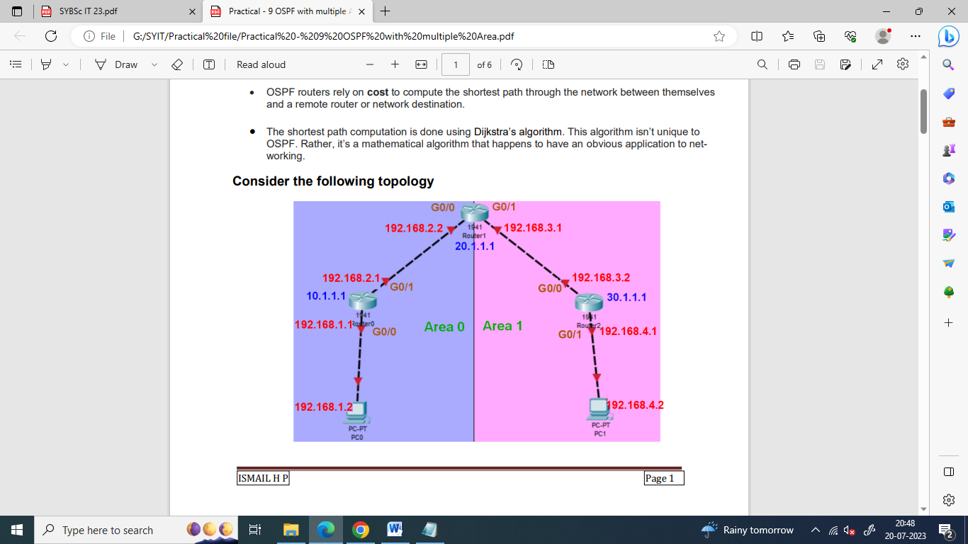

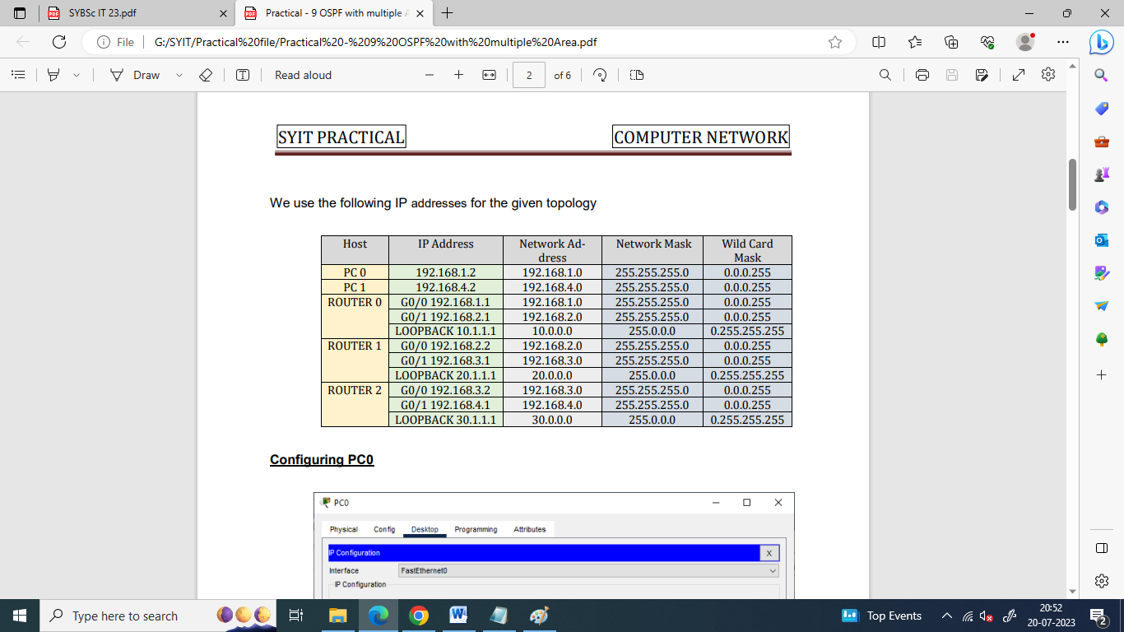

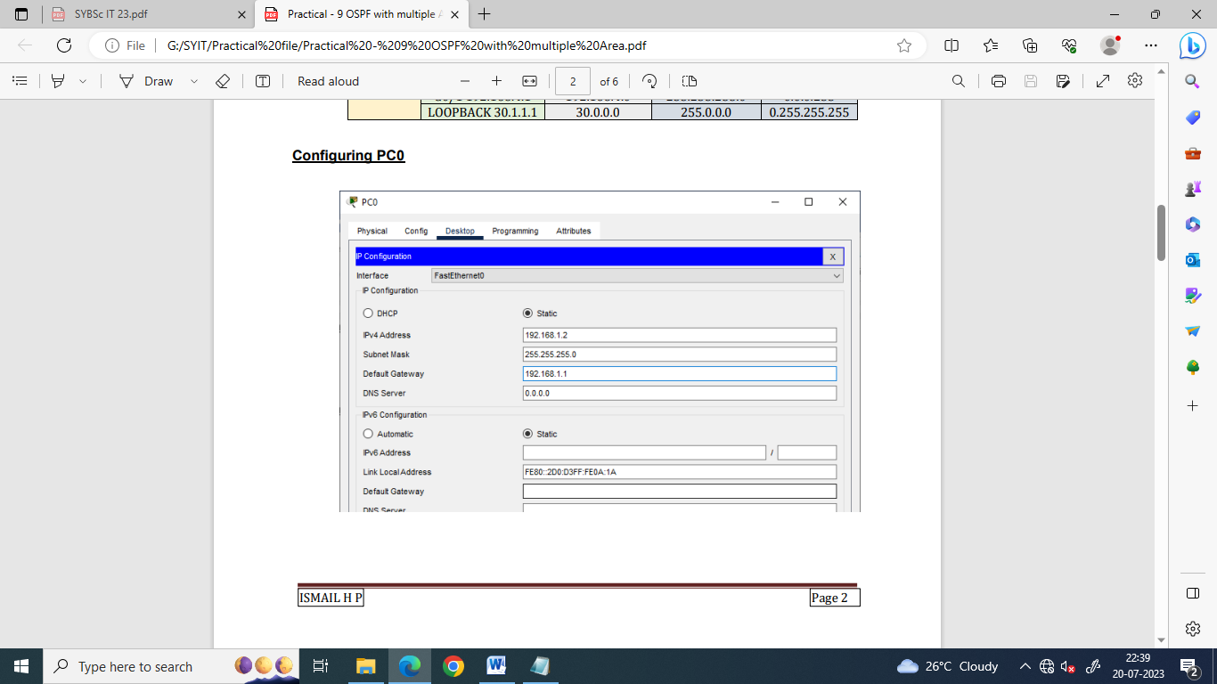

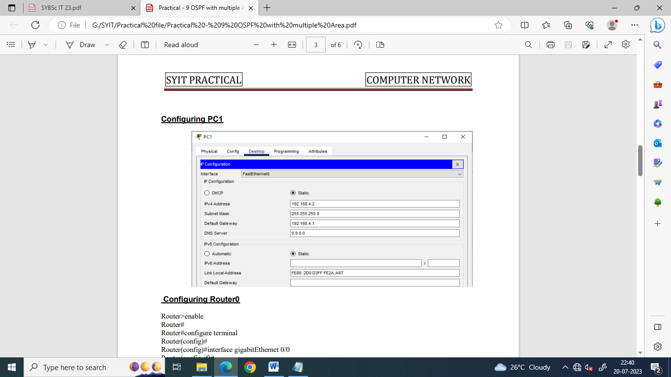

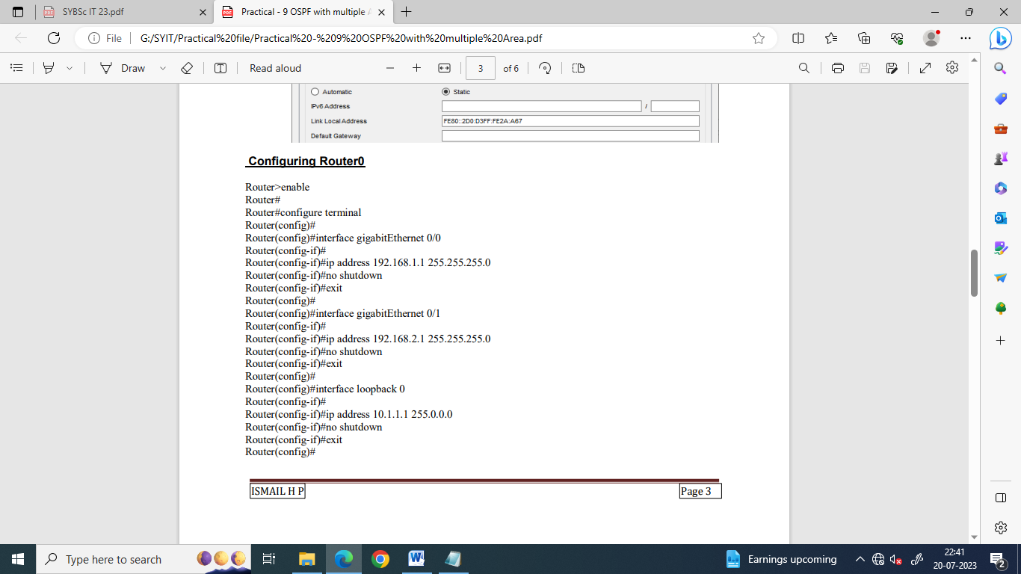



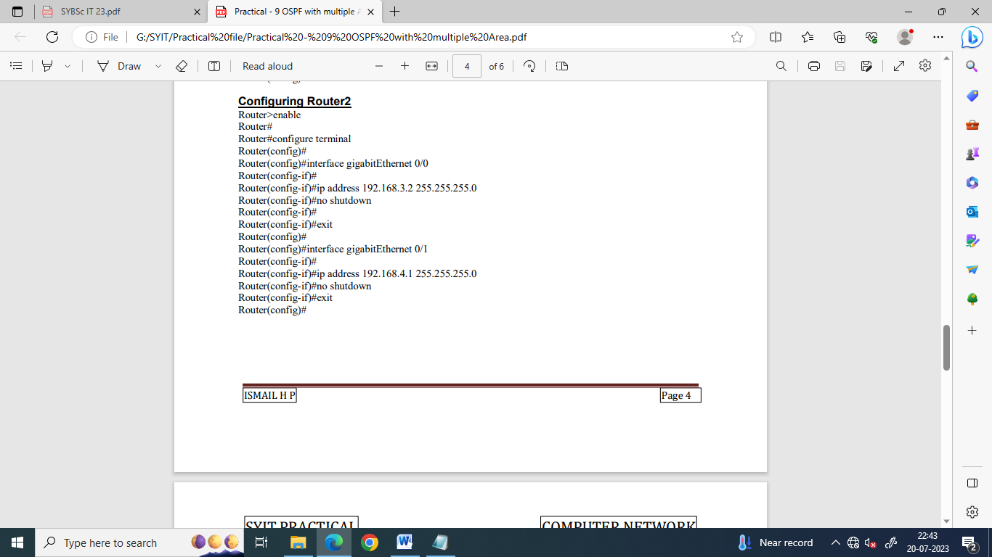

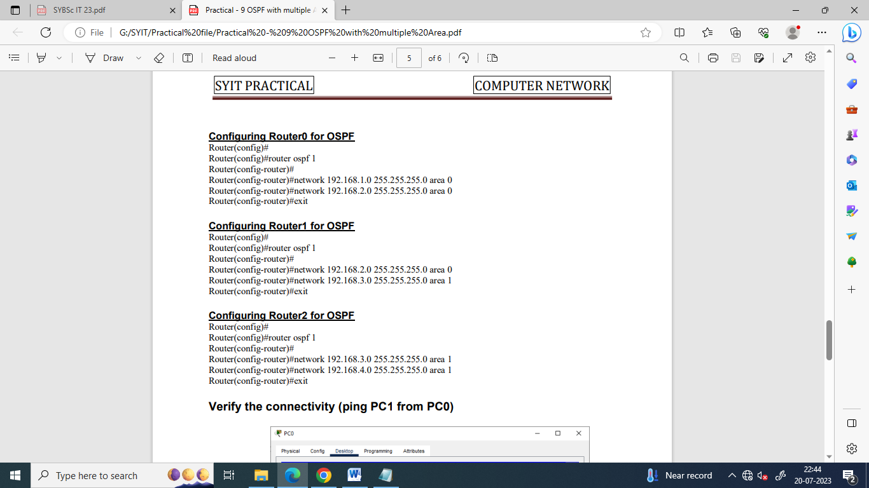

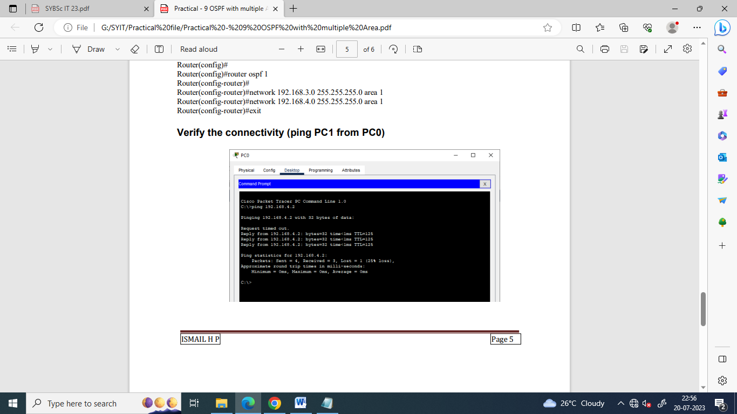

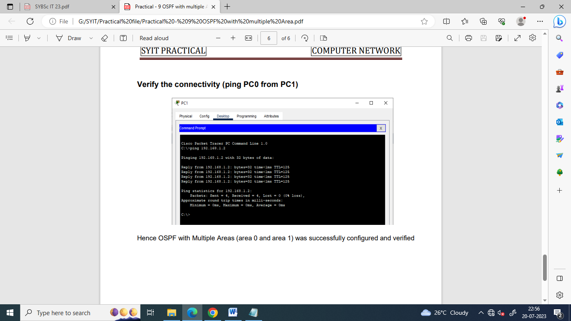

**Practical 7**

**Configuring server and client**

**Aim:** Configure the following Servers using a suitable topology

1. Configure DHCP
2. Configure DNS
3. Configure HTTP
4. Configure Telnet
5. Configure FTP
6. **Configure DHCP**

DHCP, which stands for Dynamic Host Configuration Protocol, is a standardized network protocol used to automatically assign and manage IP addresses and other network configuration parameters to devices on a network. It is an essential component of most modern computer networks, including local area networks (LANs) and larger networks such as the Internet.

The primary purpose of DHCP is to simplify the process of configuring IP addresses and related network settings for devices, such as computers, smartphones, tablets, and other network-enabled devices. Without DHCP, network administrators would need to manually assign unique IP addresses to each device on the network, which could be time-consuming and prone to errors.

In order to configure the DHCP server, we do the following

We use the following topology

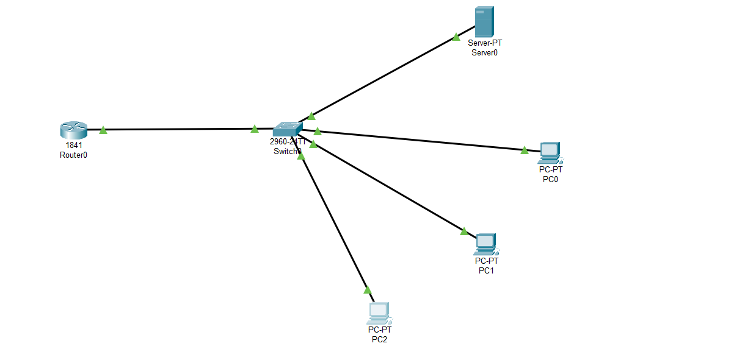

We assign the following IP addresses

|  | IP address | Subnet  Mask |
| --- | --- | --- |
| Router  Interface G0/0 | 10.0.0.1 | 255.0.0.0 |
| Server | 10.0.0.2 |
| PC0 | Will be assigned by DHCP server |
| PC1 |
| PC2 |

**Configuring the Devices:**

**Router0:**

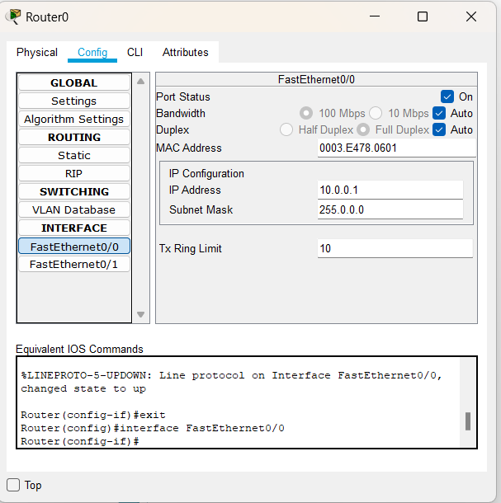

**Server:**

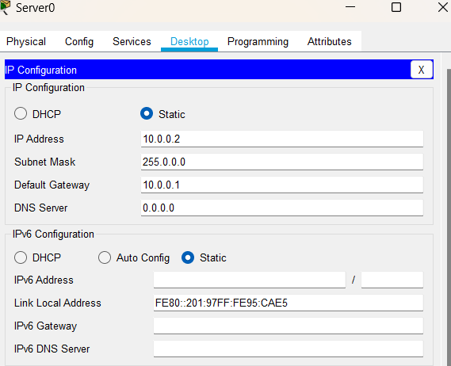

**Setting the Server for DHCP service:**

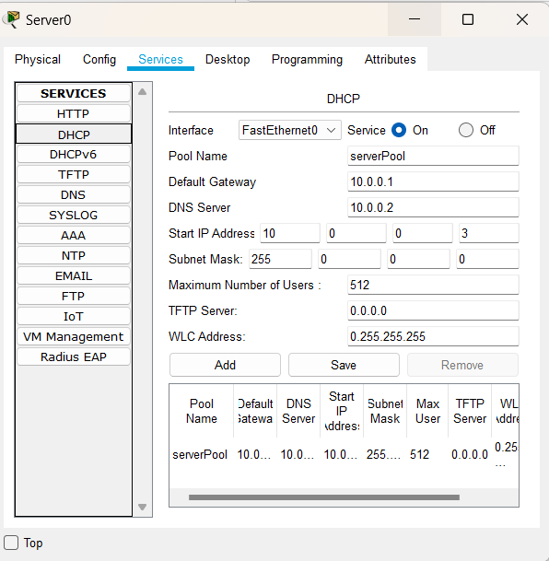

In order to verify the working of the DHCP protocol, we do the following for all the PCs

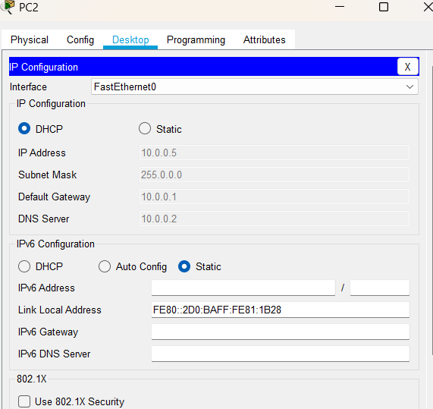

1. **Configure DNS**

DNS stands for Domain Name System. It is a fundamental part of the internet infrastructure and serves as a decentralized system for translating human-readable domain names into IP addresses, which are used by computers to identify each other on the internet.

When we type a website's domain name into your web browser (e.g., www.ismile.com), the DNS comes into play. The DNS acts as a phonebook for the internet, converting the domain name into the corresponding IP address (e.g., 192.0.2.1) that represents the actual location of the website's server on the internet.

We use the following topology

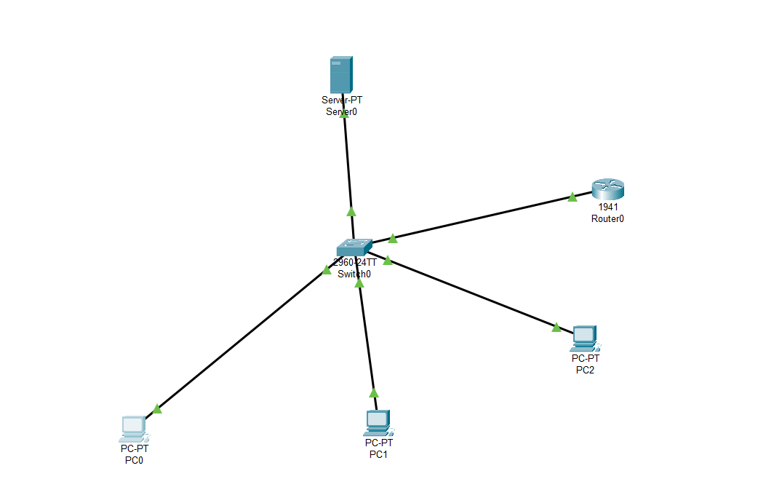

We use the following IP addresses for the given topology

|  | IP address | Default Gateway | Subnet  Mask | DNS  Server |
| --- | --- | --- | --- | --- |
| Router  Interface G0/0 | 10.0.0.1 |  | 255.0.0.0 | 10.0.0.2 |
| Server | 10.0.0.2 | 10.0.0.1 |
| PC0 | 10.0.0.3 |
| PC1 | 10.0.0.4 |
| PC2 | 10.0.0.5 |

**Configuring the Devices:**

**Router0:**

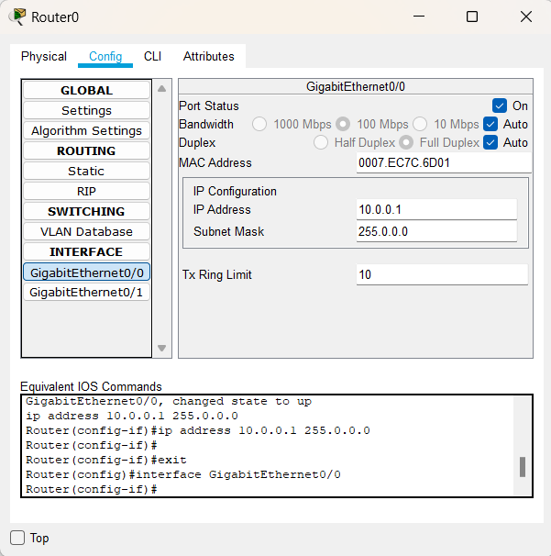

**Server:**

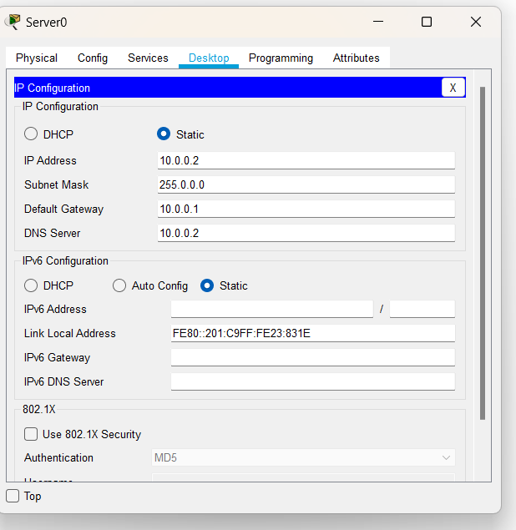

**Setting the Server for DNS service:**

We set the website ismile.com on the Server (10.0.0.2)

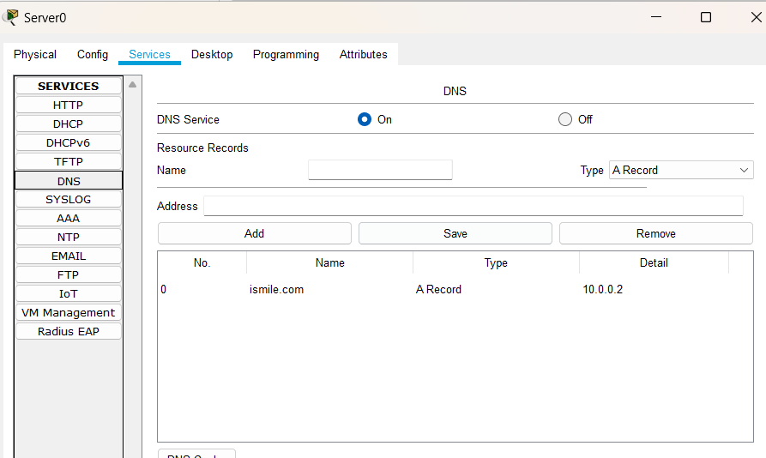

**PC0:**

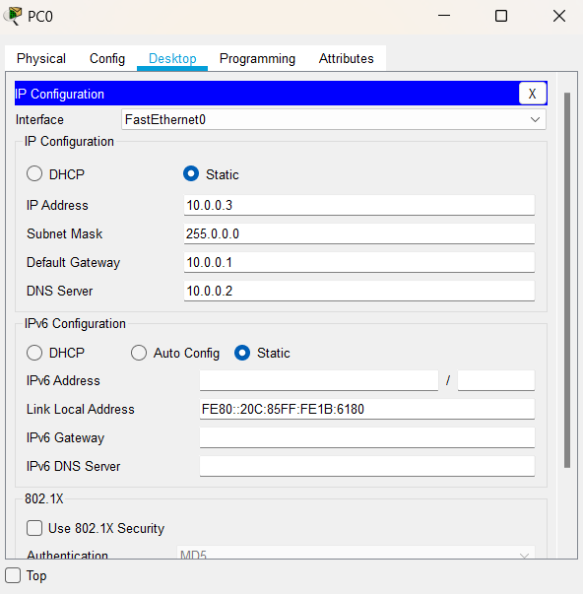

**PC1:**

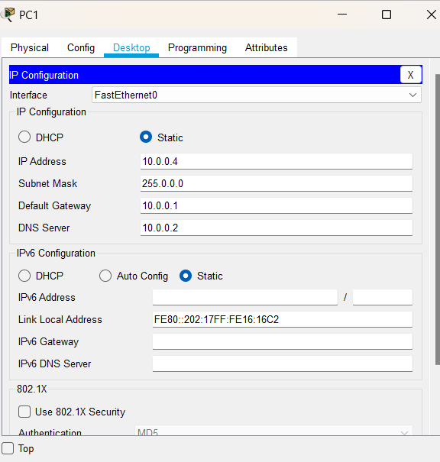

**PC2:**

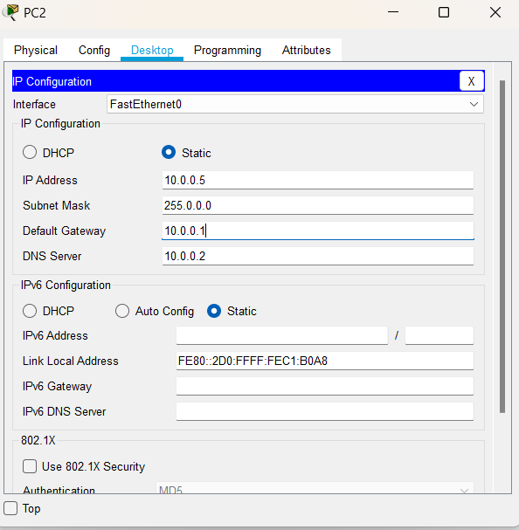

We verify the working of DNS as follows:

(Open the web browser of any PC and type [ismile.com](http://www.ismile.com) in the address bar)

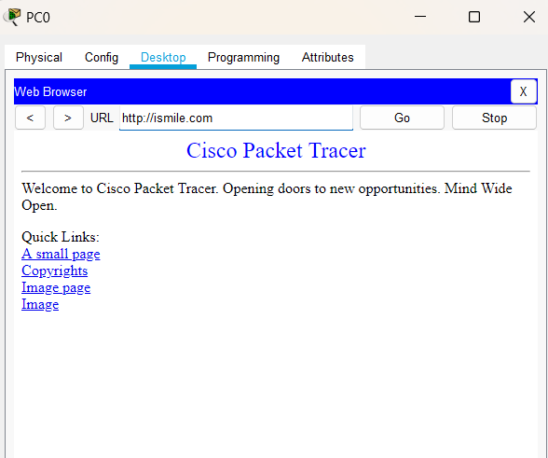

**3) Configure HTTP**

HTTP stands for Hypertext Transfer Protocol. It is an application layer protocol used for transmitting and receiving data over the internet. HTTP is the foundation of data communication on the World Wide Web and is the standard protocol used for accessing websites, retrieving resources, and interacting with web servers.

When we type a URL (Uniform Resource Locator) into your web browser and press Enter, the browser uses HTTP to communicate with the web server hosting the website and request the specified resource (such as a web page, image, video, etc.). The server then responds by sending back the requested resource, and the browser interprets the data received to display the web page or resource to the user

We use the following topology

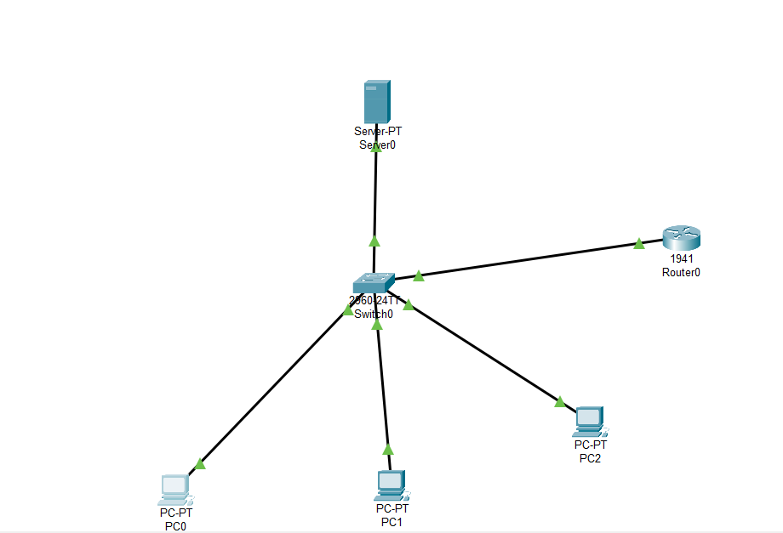

We use the following IP addresses for the given topology

|  | IP address | Default Gateway | Subnet  Mask | DNS  Server |
| --- | --- | --- | --- | --- |
| Router  Interface G0/0 | 10.0.0.1 |  | 255.0.0.0 | 10.0.0.2 |
| Server | 10.0.0.2 | 10.0.0.1 |
| PC0 | 10.0.0.3 |
| PC1 | 10.0.0.4 |
| PC2 | 10.0.0.5 |

**Configuring the Devices:**

**Router0:**

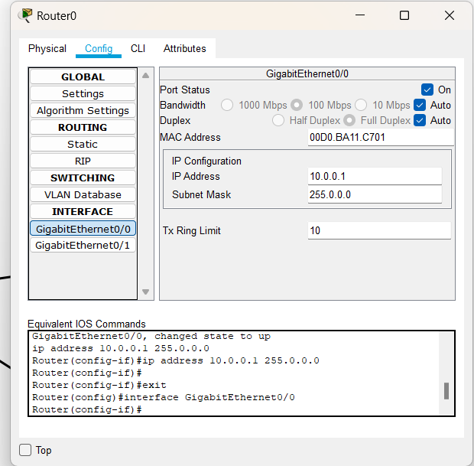

**Server:**

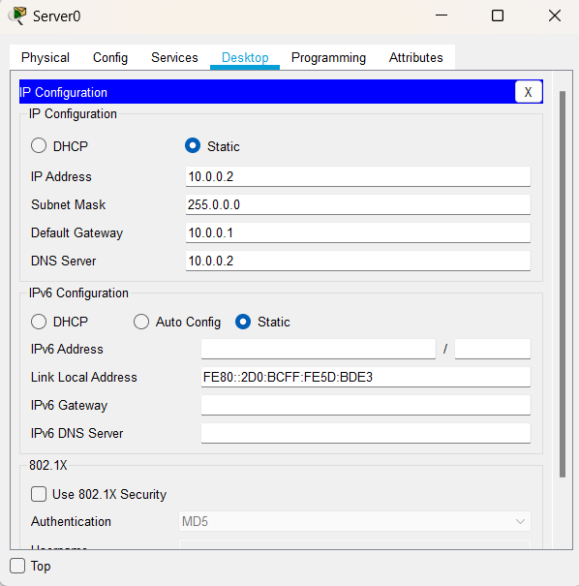

**Setting the Server for DNS service: (For HTTP we need to do set a website)**

We set the website ismile.com on the Server (10.0.0.2)

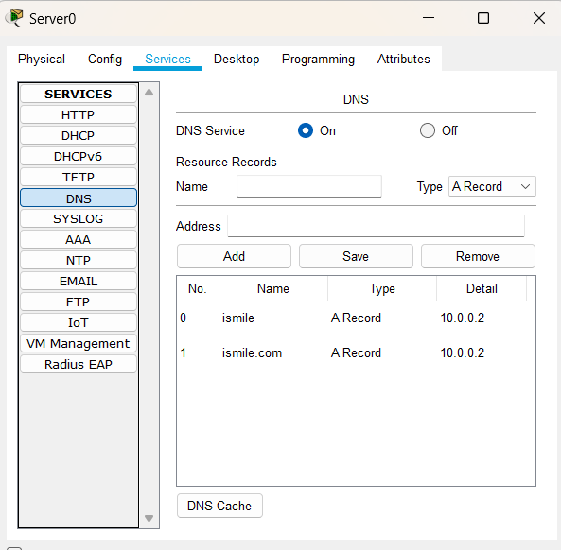

**Setting the Server for HTTP service:**

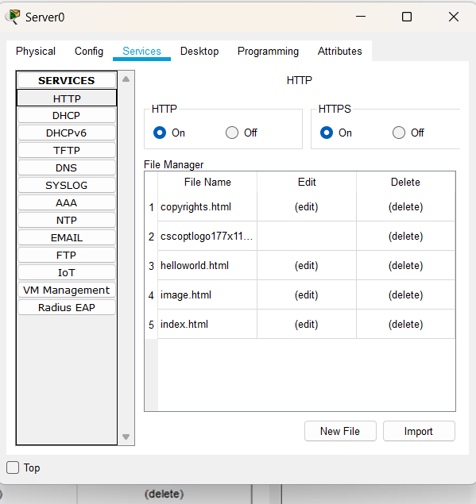

**PC0:**

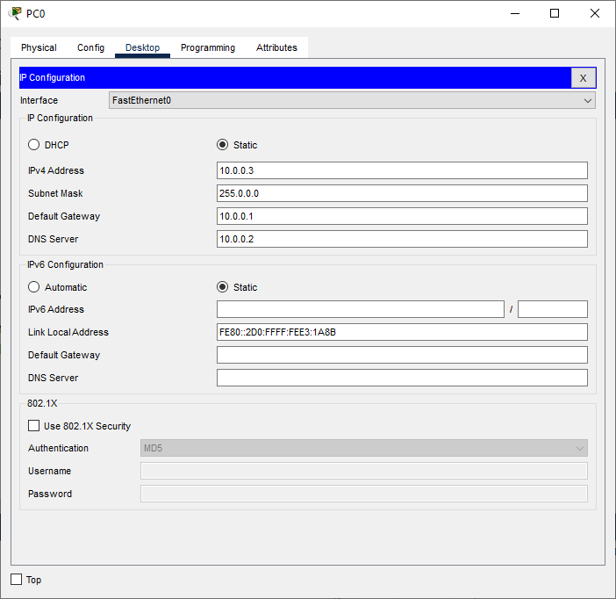

**PC1:**

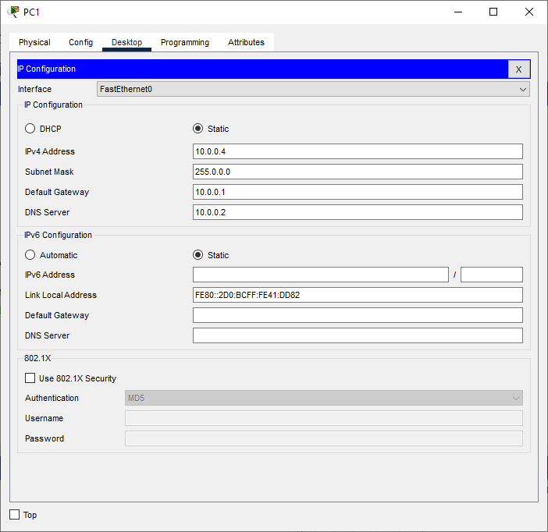

**PC2:**

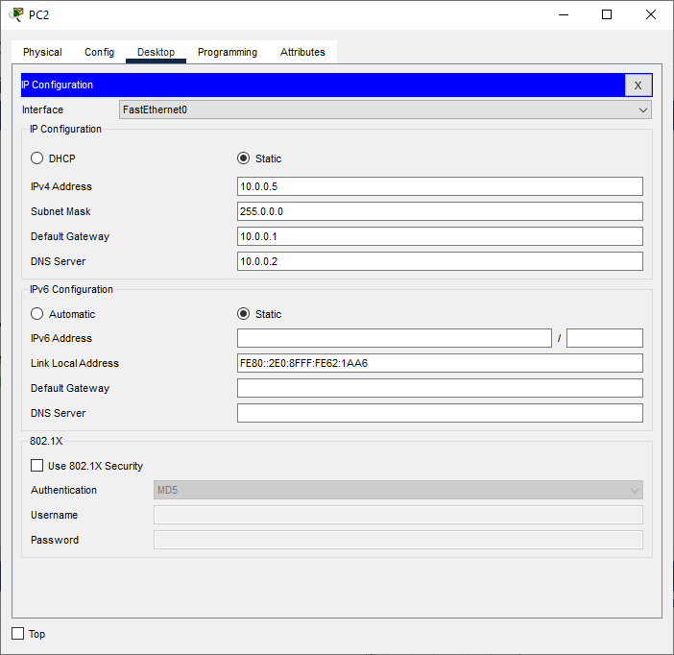

We verify the working of HTTP as follows:

(Open the web browser of any PC and type [ismile.com](http://www.ismile.com) in the address bar)

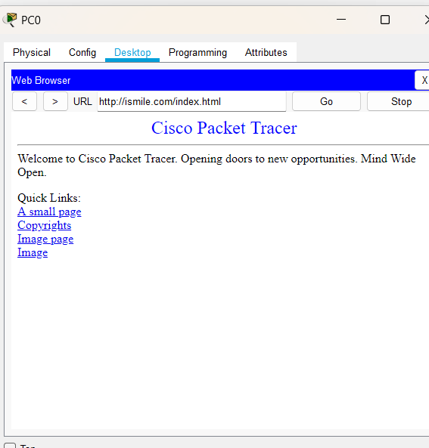

If we click on A small page we get the following.

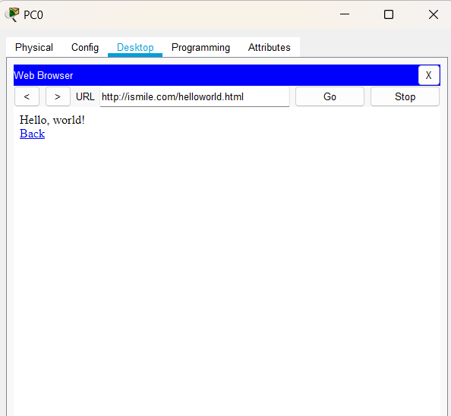

**C) Configure TELNET**

TELNET stands for "TErminal NETwork," and it is a network protocol used to establish a text-based interactive communication session between two devices over a computer network. It was one of the earliest protocols used to connect and communicate with remote computers.

In a TELNET session, one device acts as the client, and the other as the server. The client device initiates the connection to the server, and once the connection is established, the client can interact with the server through a command-line interface.

Originally, TELNET was primarily used for remote login and terminal access to mainframe computers and other multi-user systems. It allowed users to access resources and services on a remote machine as if they were sitting in front of it. However, due to security concerns, TELNET has largely been replaced by more secure protocols like SSH (Secure Shell), which encrypts the data transmitted over the network and provides better protection against unauthorized access and eavesdropping

We use the following topology

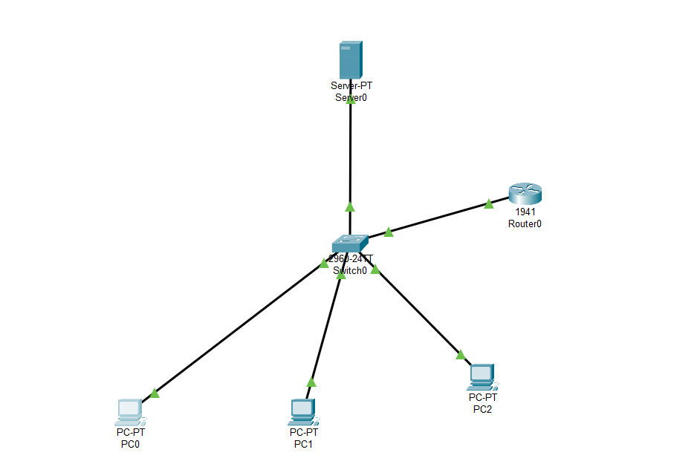

We use the following IP addresses for the given topology

|  | IP address | Default Gateway | Subnet  Mask |
| --- | --- | --- | --- |
| Router  Interface G0/0 | 10.0.0.1 |  | 255.0.0.0 |
| Server | 10.0.0.2 | 10.0.0.1 |
| PC0 | 10.0.0.3 |
| PC1 | 10.0.0.4 |
| PC2 | 10.0.0.5 |

**Configuring the Devices:**

**Router0:**

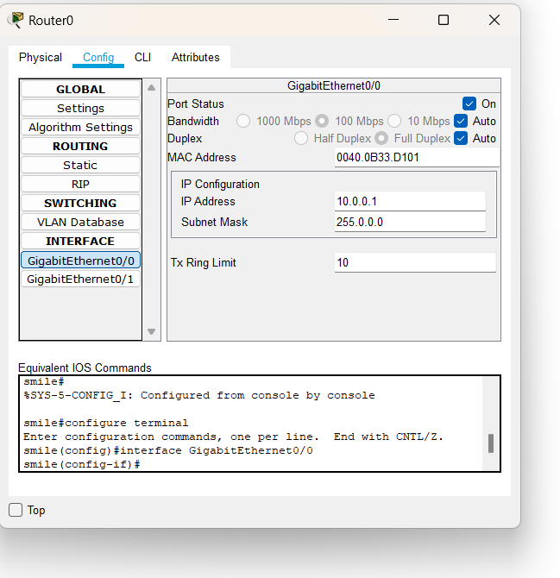

**Server:**

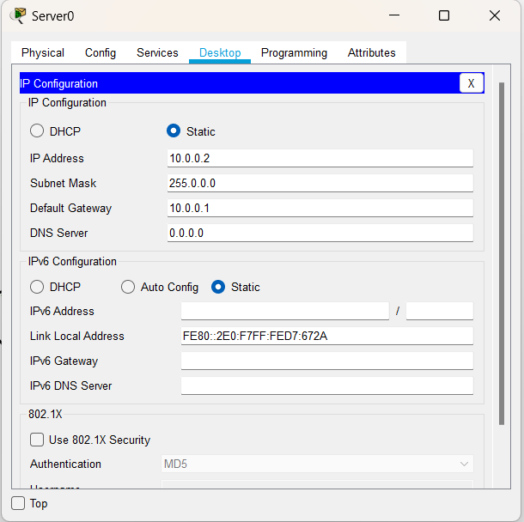

**PC0:**

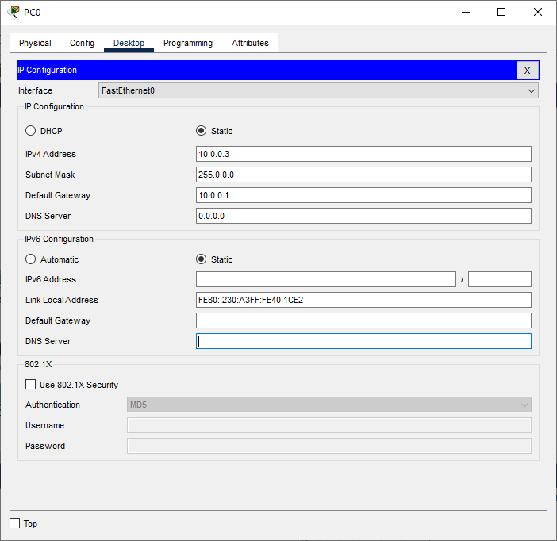

**PC1:**

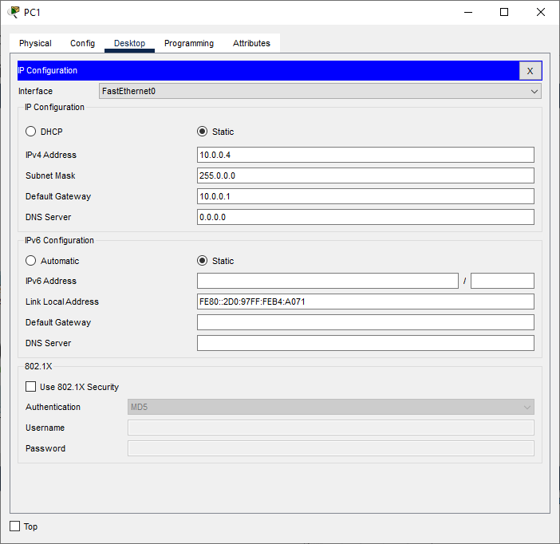

**PC2:**

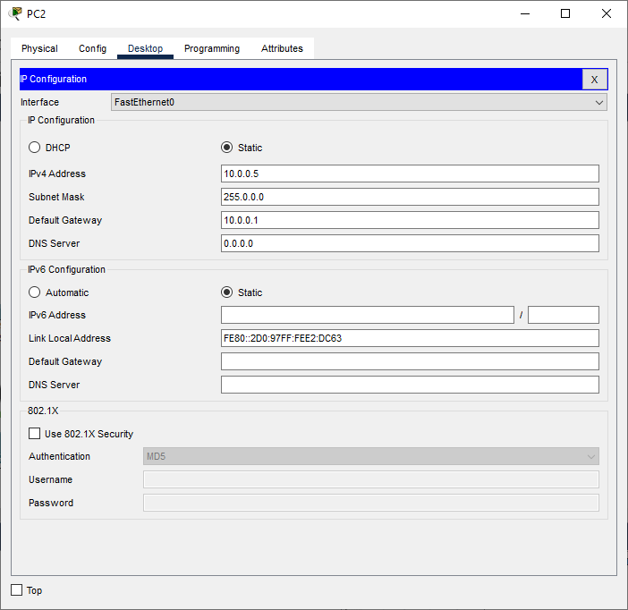

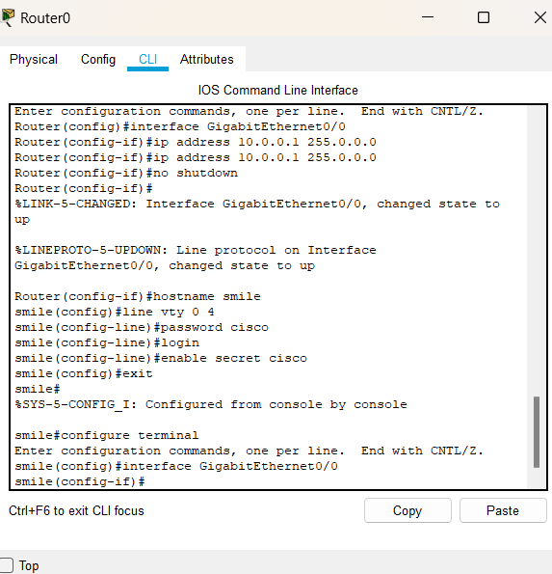

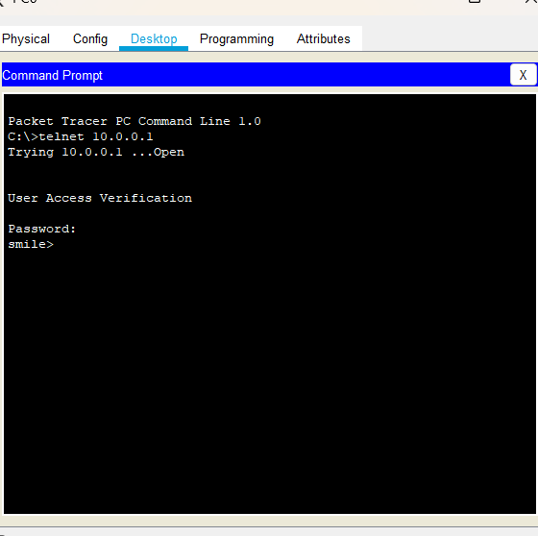

1. **Configure FTP**

FTP stands for "File Transfer Protocol." It is a standard network protocol used to transfer files between a client and a server on a computer network, such as the Internet or an intranet. FTP allows users to upload and download files, as well as perform various file operations on remote systems.

The FTP communication typically involves two entities: the FTP client and the FTP server. The FTP client is the software running on the user's local computer that initiates the file transfer request, and the FTP server is the remote system that stores and manages the files.

We use the following topology

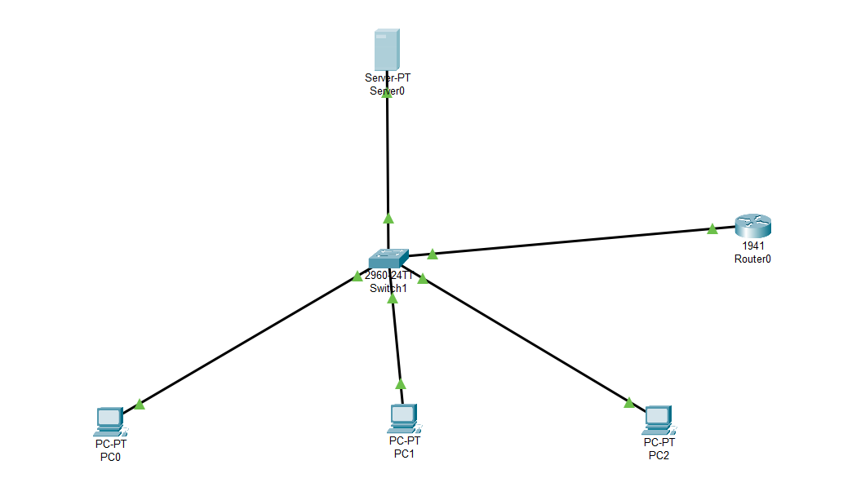

We use the following IP addresses for the given topology

|  | IP address | Default Gateway | Subnet  Mask |
| --- | --- | --- | --- |
| Router  Interface G0/0 | 10.0.0.1 |  | 255.0.0.0 |
| Server | 10.0.0.2 | 10.0.0.1 |
| PC0 | 10.0.0.3 |
| PC1 | 10.0.0.4 |
| PC2 | 10.0.0.5 |

**Configuring the Devices:**

**Router0:**

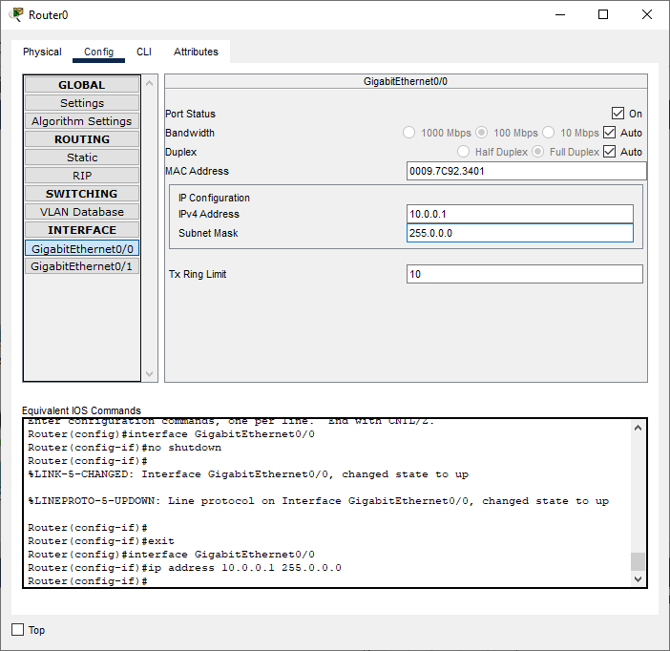

**Server:**

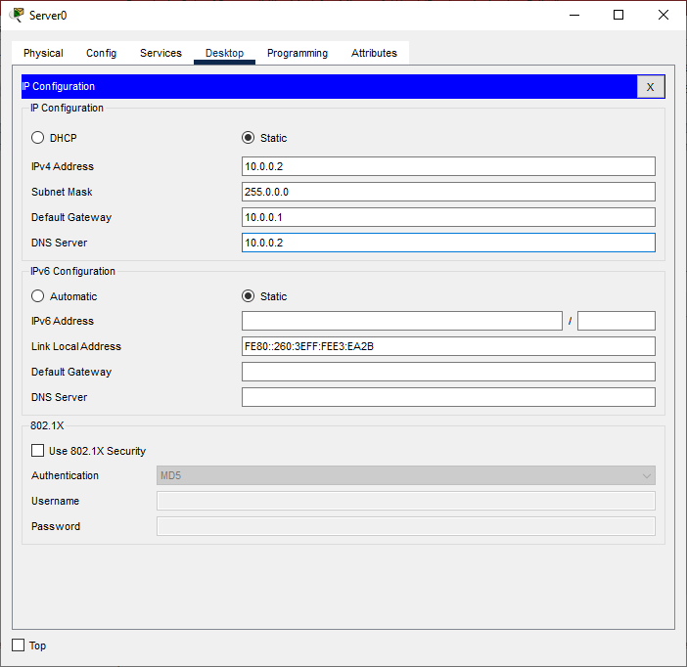

**Configure the Server for FTP service as follows**

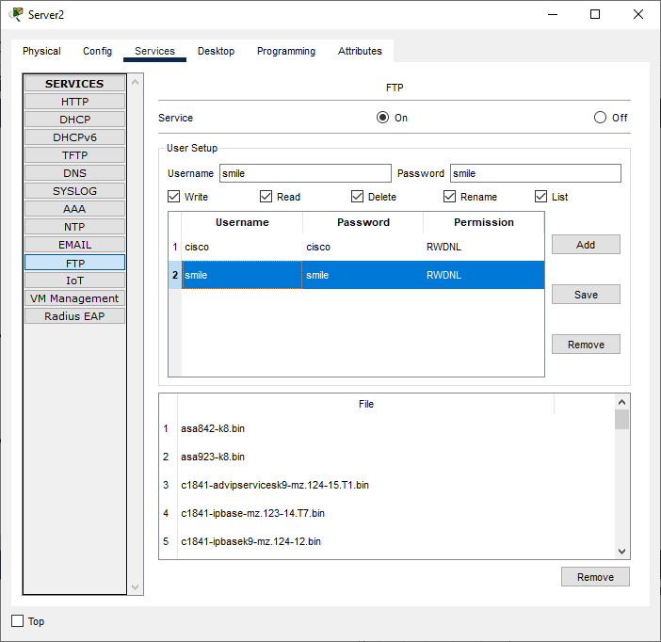

**PC0:**



**PC1:**



**PC2:**



